

Jewelry That Cares: Harnessing Smart Jewelry for Emotional Well-being

Capstone Project Phase B

by. Gal Polak & Michal Ginat

advisor. Dr. Naomi Unkelos Shpigel

Software Engineering Department

Project Code : 24-2-D-7

GitHub Phase A:<https://github.com/MichalGinat/Smart-Jewelry>

GitHub Phase B:<https://github.com/GalPolak98/CozySpace>

Project video: [Cozy Space - Walkthrough](https://youtu.be/wCzhLLFTE7A)



*Table of Contents:*

Abstract 4

1. Introduction 4

2. Literature Review 5

2.1 Prevalence of Anxiety 5

2.2 Cognitive Behavioral Therapy (CBT) for Anxiety Management 6

2.3 Existing Application Introduction 7

2.4 Managing Anxiety with Smart Wearables and Smart Apps 9

2.5 A Comprehensive Review of Anxiety Detection Techniques: Challenges, Methods, and Emerging Trends 9

3. Engineering Process 11

3.1 Development Process 11

3.2 System Architecture Overview 13

3.2.1 Technology Stack 13

4. Work Artifacts 15

4.1 Use Case Diagram 15

4.2 Activity Diagram 16

4.2.1 Patient and the system 16

4.2.2 Therapist and the system 16

4.3 Working Flow Diagram 17

5. Challenges & Solutions 17

6. Evaluation 18

6.1 SUS Survey 18

6.2 Evaluation Summary 21

7. Results and Conclusions 21

7.1. Lessons learned 22

7.2. Project metrics 22

8. User Guide 23

8.1 Introduction Page - welcome 23

8.1.1 Introduction Page - Real Time Support 23

8.1.2 Introduction Page - Track Your Journey 24

8.1.3 Introduction Page - Connect With Care 25

8.2 Login Page 26

8.3 Sign Up Page 27

8.4 Onboarding Page - Role Selection 28

8.5 Onboarding Page - Personal Information 29

8.6 Patient 30

8.6.1 Onboarding Page - Connect with a Therapist (initial) 30

8.6.2 Onboarding Page - Connect with a Therapist (after choosing) 31

8.6.3 Onboarding Page - Customize Your Experience 32

8.6.4 Onboarding Page - Onboarding Complete 33

8.6.5 Monthly Mental Health Assessment Page 34

8.6.6 Navigation Top bar (Logged in state) 35

8.6.7 Navigation Button bar (Logged in state) 35

8.6.8 Home Page 36

8.6.9 AI Chat page 36

8.6.10 Guided Documenting Page 37

8.6.11 Direct Documenting Page 38

8.6.12 Breathing Exercises Page 39

8.6.13 Profile Page 40

8.6.14 Reports Page 42

8.6.15 Information Page 43

8.6.16 Notes Screen 44

8.6.17 Edit Notes Screen 45

8.6.18 Recordings Screen 46

8.7 Therapist 47

8.7.1 Professional Background Page 47

8.7.2 Onboarding Page - Onboarding Complete 48

8.7.3 Home Page 49

8.7.4 Patient’s information Page 50

8.7.5 Analysis of DASS-21 questionnaire screen: 51

9. Maintenance Guide 52

9.1 Development Environment Setup 52

9.1.1 Prerequisites: 52

9.1.2 Repository Structure 53

9.2 Installation Instructions 53

9.2.1 Clone GitHub repository: 53

9.2.2 Backend Setup (Local Development): 53

9.2.3 Mobile Application Setup (Local Development): 54

9.2.4 Backend Deployment (Render): 54

9.2.5 Mobile App Local Build (APK): 54

9.2.6 iOS Deployment Note: 57

9.3 Environment Configuration 57

9.3.1 Server Environment Variables (.env): 57

9.3.2 Mobile App Environment Variables (.env): 58

9.4 Database Management 60

9.4.1 MongoDB Collections Structure: 60

9.5 Server Limitations (our server deployment) 63

9.5.1 Render Free Tier Limitations 63

10. References 63

# Abstract

In today's fast-paced world, managing anxiety effectively is crucial for maintaining mental health and well-being. Managing anxiety remains a significant challenge, particularly given the rising global prevalence of anxiety disorders and the lack of integrated tools offering real-time monitoring and personalized interventions. This growing burden on mental health systems necessitates innovative solutions that can bridge the gap between traditional treatments and optimize care delivery for larger populations. This project proposes a new mobile application solution designed to address these challenges by leveraging wearable devices equipped with sensors to detect anxiety attacks. To accurately measure anxiety, the app will in the future integrate machine learning that analyzes various physiological signals, such as heart rate variability (HRV) and electrodermal activity (EDA). The app provides immediate calming actions, personal records, and detailed tracking anxiety reports. The book details the technical design, diagrams, and research underpinning this tool, including system architecture frameworks. Insights from interviews with psychologists and a review of existing solutions shaped the app's features, ensuring it meets user needs and enhances long-term mental health management.

# 1. Introduction

Anxiety disorders affect a significant portion of the global population, highlighting the urgent need for effective anxiety management solutions [8]. Recent events, such as the conflict in Israel that began on October 7, 2023, have intensified this need, leading to a noticeable rise in anxiety levels and an increase in related online searches [*13*]. These trends emphasize the growing demand for mental health support and the challenges therapists face in addressing widespread anxiety management needs [8].

To address this pressing issue, our project includes an innovative smart wearable device paired with a dedicated app for real-time anxiety management. This solution employs advanced sensors and real-time data processing to offer a non-invasive, supportive tool. The wearable device continuously monitors signals, such as Electrodermal Activity (EDA), also known as Galvanic Skin Response (GSR) and Heart Rate Variability (HRV), which are reliable indicators of stress and anxiety [3].

Extensive discussions with psychologists revealed several key challenges therapists face, including maintaining real-time situational awareness, overcoming communication barriers, and accurately tracking and documenting anxiety episodes. These challenges underscore the need for tools that facilitate effective self-management and streamline therapeutic processes.

Integrating Cognitive Behavioral Therapy (CBT) techniques is a key aspect of our approach. CBT, a well-established and evidence-based treatment, guides our inclusion of strategies such as Relaxation Training, which aligns with our goal of providing structured and practical tools for managing anxiety [1]. Our research into existing anxiety apps revealed that only a small percentage involved mental health professionals in their development [4]. In response to this gap, our platform prioritizes professional involvement to ensure that our application is grounded in expert knowledge and effectively supports both patients and therapists.

The app features comprehensive documentation options, detailed metrics for therapists, privacy controls, and tools to improve patient-therapist contact. This comprehensive approach ensures that the application meets the real-world needs of its users and integrates the best practices from both research and clinical experience.

The app bridges the gap between therapy sessions by providing real-time anxiety management support. When patients choose to share their app-generated reports with therapists, they gain valuable insights into their patients' anxiety patterns and responses between sessions. This data-driven approach enables more informed treatment decisions and targeted interventions, ultimately enhancing the effectiveness of traditional therapy.

The rest of the book details the app's technological implementation, features, and evaluation findings. Through case studies and expert insights, the book demonstrates the app's effectiveness across diverse anxiety scenarios and its successful integration with therapeutic practices. The evaluation results highlight how the app's real-time monitoring and intervention capabilities complement traditional therapy approaches.

## 2. Literature Review

# 2.1 Prevalence of Anxiety

Anxiety regularly maintains a fairly constant trend in terms of the Google searches that are created due to anxieties and their treatment. According to search data, there are dozens of weekly searches on the subject of anxiety, indicating its daily impact on people's lives[13].

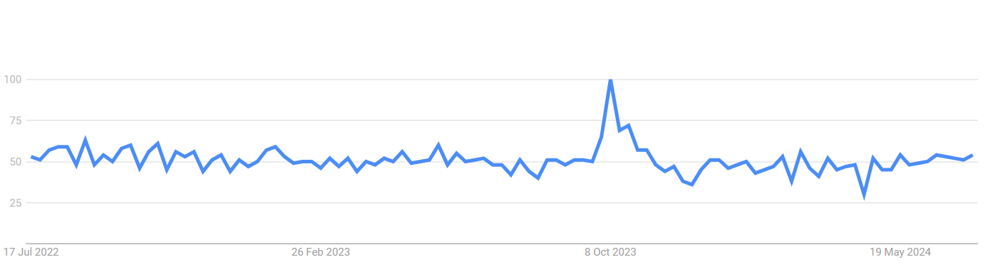

*fig 1. ‘Anxiety’ on google trends [13]*

Statistics show that globally, anxiety disorders affect approximately 4% of the population, translating to 301 million people as of 2019 [8]. The onset of the war further intensified this interest according to the findings from Google searches [13], highlighting the urgent need for mental health support and exacerbating the existing challenges therapists face in addressing the widespread demand for anxiety management.

The research carried out on the epidemiology of anxiety disorders highlights several critical points that relate closely to our application. Firstly, the global prevalence of anxiety disorders and their increase over the years emphasizes the significant and growing need for effective anxiety management solutions [8].

Additionally, the study underscores the importance of sociodemographic factors in the prevalence and management of anxiety disorders. It was found that anxiety is more prevalent in high-income regions and among women [8]. This insight is crucial for our application development, as it suggests the need for tailored features that consider these sociodemographic differences. By customizing interventions and providing personalized feedback, our application can offer more effective and inclusive support to a diverse user base.

# 2.2 Cognitive Behavioral Therapy (CBT) for Anxiety Management

Cognitive Behavioral Therapy (CBT) is a well-established, evidence-based treatment for anxiety disorders. It focuses on helping patients identify and challenge negative thought patterns and behaviors associated with anxiety.

Key techniques in Cognitive Behavioral Therapy (CBT) include **Cognitive Restructuring**, which helps patients identify and challenge irrational or maladaptive thoughts, replacing them with more realistic and positive ones [1]. **Exposure Therapy** involves gradual exposure to feared situations or objects to reduce anxiety, particularly effective for phobias, panic disorder, and PTSD [1][9]. **Mindfulness-Based Cognitive Therapy (MBCT)** combines traditional cognitive therapy with mindfulness strategies to prevent the recurrence of depression and reduce anxiety [9]. **Behavioral Activation** encourages engagement in positive activities to improve mood and counteract avoidance, withdrawal, and inactivity [9]. **Acceptance and Commitment Therapy (ACT)** emphasizes accepting unpleasant thoughts and feelings rather than resisting them, encouraging commitment to actions aligned with personal values [9]. **Dialectical Behavior Therapy (DBT)** integrates cognitive-behavioral techniques with mindfulness, especially effective for treating borderline personality disorder and emotional dysregulation [9]. **Functional Analytic Psychotherapy** focuses on improving interpersonal relationships through therapeutic interactions that teach new behaviors [9]. **Relaxation Training** includes techniques such as deep breathing, progressive muscle relaxation, and guided imagery to reduce physical symptoms of stress and anxiety [1].

Recent Advances and Meta-Analyses: show the effectiveness of CBT in reducing anxiety symptoms and improving the quality of life for patients with anxiety disorders. These studies highlight significant positive outcomes for both individual and group therapy formats [1​]. CBT provides long-term benefits in anxiety management, with patients maintaining improvements well beyond the end of treatment [1]​​[9]​.

CBT has been proven effective for various anxiety-related disorders, including generalized anxiety disorder (GAD), social anxiety disorder (SAD), panic disorder, and post-traumatic stress disorder (PTSD) [1]. Given our project's focus on a target population treated with CBT, understanding and integrating CBT techniques is crucial.

# 2.3 Existing Application Introduction

In the realm of mental health and wellness, numerous apps have been developed to help individuals manage stress, anxiety, and overall mental well-being. These apps employ a range of features, including professional involvement, gamification, and social interaction, to enhance user experience and effectiveness.

A comprehensive study published in the Journal of Biomedical Informatics [4] analyzed 167 highly rated, free anxiety apps. The study categorized these apps based on their intervention approaches, professional involvement, gamification features, and social functionalities.

**Intervention Approaches:** The most common methods used were mindfulness (29 apps) and Cognitive Behavioral Therapy (CBT) (25 apps). Other approaches included hypnotherapy, artificial intelligence, brainwaves and frequencies, Dialectical Behavioral Therapy (DBT), and Autonomous Sensory Meridian Response (ASMR). Less common methods included Acceptance Commitment Therapy (ACT), spiritual or religious practices, biofeedback, and Positive Psychology.

**Professional Involvement:** Despite the effectiveness of these apps, only 19% of them reported involvement from mental health professionals in their development.

**Gamification Features:** Gamification was used in 51% of the apps to boost user engagement. Common features included games, graphics, goals, levels, challenges, and the ability to unlock new features or earn rewards.

**Social Features:** 32% of the apps incorporated social features such as chat, progress sharing, links to relevant resources, and emergency contact information.

In response to the limited availability of anxiety apps with professional involvement, we have developed a new platform that incorporates this critical feature among others.

The following findings provide a detailed comparison of two prominent devices that interface with anxiety management applications: the **Spire Stone** and the **Feel by Sentio Solutions** [23] [24].

|  |  |  |
| --- | --- | --- |
| **Feel by Sentio Solutions** | **Spire Stone** | **Feature** |
| Modern wristband; worn on the wrist | Small, stone-shaped device; clips onto clothing | Design and Wearability |
| Multi-sensor: HRV, skin conductance, temperature | Respiratory sensors; tracks breathing patterns, activity | Sensors and Monitoring |
| Real-time alerts for elevated stress; personalized recommendations | Real-time alerts for stress detected via breathing patterns; prompts breathing exercises | Alerts and Notifications |
| iOS and Android | iOS and Android | Mobile App Features |
| Up to 24 hours on a single charge | Around 7 days on a single charge | Battery Life |
| USB cable | Wireless charging pad | Charging |
| Water-resistant (suitable for everyday use, not for swimming) | Water-resistant (suitable for everyday use, not for swimming) | Water Resistance |
| Customizable color options; more variety in design | Limited color options; typically, available in basic colors | Personal Design (Color) |
| Adjustable wristband; fits most wrist sizes | One-size-fits-all; clips onto clothing | Size |
| Some gamifications; includes mood tracking and progress milestones | Limited gamification; focuses on mindfulness and breathing exercises | Gamification Features |
| Significant; developed with mental health professionals' input, includes access to licensed therapists | Limited; focused on mindfulness and breathing, with no direct professional input or support | Professional involvement |
| No built-in feature for notes or recording; focuses on real-time feedback and recommendations | No built-in feature for notes or recording; relies on app insights | Documenting Experience |
| Guided Breathing Exercises: Breath Awareness, Stress-Relief Breathing  Mindfulness and Meditation: Guided Meditation Sessions, Body Scan  Mood Tracking and Recommendations: Personalized Recommendations, Daily Check-Ins | Guided Breathing Exercises: Deep Breathing, Focused Breathing  Mindfulness Meditation: Short Meditations, Mindfulness Reminders  Breathing Exercises for Different States: Calm, Focus | Relaxing Exercises |

*Table1: existing devices examination*

This table compares two anxiety management wearables—Feel by Sentio Solutions and Spire Stone—highlighting their key features to support users in managing stress and anxiety. It covers aspects like mobile app compatibility, sensor technology, and personalized recommendations, helping users identify which device best suits their needs. While both tools offer valuable features for anxiety management, neither provides a fully integrated solution that addresses all aspects of mental well-being. To fill this gap, we aim to develop a solution that would combine essential features like professional support, personalized insights, and real-time monitoring into a single, user-friendly platform.

# 2.4 Managing Anxiety with Smart Wearables and Smart Apps

The integration of wearable devices with mobile applications has become essential for effectively managing anxiety and other mental health conditions. Wearable sensors, such as electrodermal activity (EDA) and heart rate monitors, allow continuous monitoring of physiological signals, providing real-time detection of stress and anxiety. When paired with smart applications, these devices offer personalized feedback and interventions, helping users manage their anxiety more effectively. For instance, the DEWS project demonstrates the potential of wearable systems to offer real-time health monitoring and timely alerts, which can be crucial for handling acute anxiety episodes and potentially saving lives [2]. Additionally, smart devices equipped with advanced algorithms provide actionable insights and recommendations, enabling users to adopt calming strategies and make informed decisions about their mental health [6]. The incorporation of IoT technology enhances these capabilities by ensuring seamless communication between devices and healthcare providers, enabling continuous data flow and timely interventions. This technology not only enhances individuals' ability to cope with anxiety but also supports healthcare professionals in delivering more targeted and efficient care.

# 2.5 A Comprehensive Review of Anxiety Detection Techniques: Challenges, Methods, and Emerging Trends

Measuring anxiety involves capturing how individuals respond to anxiety through various physiological and physical signals. Given that anxiety manifests differently from person to person, influenced by factors such as body condition, age, gender, and experience, establishing universally accepted numerical values for anxiety indicators remains challenging.

To address these variables, computational techniques like artificial neural networks and fuzzy logic are employed to manage the uncertainties in defining stress *[10]*. As a result, machine learning is increasingly utilized to improve anxiety detection.

Interestingly, traditional psychophysiology studies, which do not utilize machine learning techniques, often fail to show significant correlations between physiological measures and subjectively rated anxiety levels. This highlights a critical limitation of conventional methods, which can struggle to accurately detect anxiety. The study *[7*] found that traditional methods alone were insufficient for accurate anxiety detection, reinforcing the importance of integrating deep learning to achieve more precise and reliable results.

Common methods for assessing anxiety include analyzing physiological signals such as electroencephalography (EEG), blood volume pulse (BVP), heart rate variability (HRV), galvanic skin response (GSR), and electromyography (EMG). Additionally, physical signals including eye gaze, pupil diameter, voice characteristics, and facial movements are also monitored. Figure 2 illustrates the common physical and physiological measures used to detect stress and their typical sources.

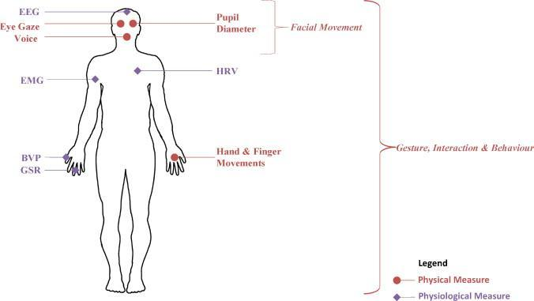

*fig 2. usual sources for the measures [10]*

Under anxiety, notable changes occur in heart rate, blood pressure, pupil diameter, breathing patterns, and galvanic skin response. Electrodermal Activity (EDA), also known as GSR, measures variations in skin electrical conductance, which increases with emotional arousal and stress due to sweating. The data indicates that Electrodermal Activity (EDA), heart rate (HR), and accelerometers are among the most prevalent physiological signals utilized for stress detection *[3*]. Notably, the combination of EDA and HR has demonstrated the highest performance in these settings, with accuracies surpassing 95%. The research also highlights that Linear Discriminant Analysis (LDA), Support Vector Machines (SVM), k Nearest Neighbors (kNN), and Fuzzy Logic classifiers are some of the most effective machine learning algorithms for detecting anxiety. For instance, EEG signals achieved an 89% accuracy in four-class stress classification; however, the use of EEG devices remains challenging due to their obtrusiveness in everyday scenarios.

After a thorough search for suitable models, including a review of neat code with a dataset and referenced articles, we discovered a valuable resource available *[18*]. The repository contains code for anxiety level detection in arachnophobe individuals using supervised machine learning algorithms. The physiological signals used include ECG (Electrocardiogram), GSR (Galvanic Skin Response), and RESP (Respiratory signal). These signals were pre-processed, and the necessary features were extracted. The dataset can be downloaded from the provided link.

Remarkably, this approach achieved an accuracy of 89.8% for two-level classification and 74.4% for three-level classification using a short time window length of ten seconds. The method utilized subjective ratings for data labeling, and Bagged Trees proved to be the most suitable classifier among those studied [7]. In a related effort, another study explored the detection of subclinical social anxiety in young adults using physiological data obtained from wearable sensors, such as Heart Rate (HR), Skin Temperature (ST), and EDA [11]. The full dataset and code to recreate the classification models are available in a corresponding [19], which also includes functions for further experimentation.

Another approach to detecting anxiety involves developing our own classification model by sourcing an appropriate dataset and applying machine learning algorithms. This method would enable us to tailor the model to our specific requirements, potentially enhancing its accuracy and performance.

## 3. Engineering Process

# The engineering process encompasses the systematic steps taken to design, develop, and deploy the system. It includes creating a detailed workflow, defining the system architecture, and selecting appropriate technologies to ensure optimal performance, scalability, and security. The implementation phase followed an iterative approach, building core functionalities and gradually expanding features while maintaining continuous testing and refinement. Finally, the deployment phase focused on system optimization, documentation, and establishing deployment procedures to ensure successful system operation in the production environment.

## 3.1 Development Process

The development process of our project involved several key steps to ensure a thorough and effective application design and implementation:

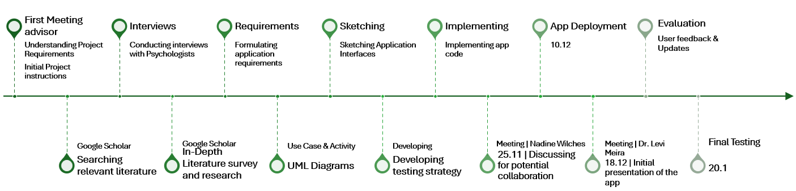

*fig 3. workflow diagram*

**Preliminary Literature Survey:** The development process began with a preliminary literature survey to better understand and focus on the main issues related to anxiety management and wearable technology. This step was crucial in identifying the most relevant trends and technologies in the field.

**Conducting Interviews:** Following the literature survey, we conducted interviews to gather opinions and gain deeper insights into the subject. These interviews helped direct what should be included in our application and identify the most needed features.

**In-Depth Literature Survey:** After the interviews, we conducted a more focused literature survey. The insights from the interviews helped us identify specific topics to delve into further, ensuring that our application addresses the most critical areas and benefits the users in the best possible way. For example, some of the calming techniques reviewed, such as Relaxation Training, will be considered for use in treating anxiety within our target population. These methods align well with our project's goals to provide effective, evidence-based anxiety management tools. Integrating these CBT techniques into our application will enable us to offer structured, practical strategies that patients can use to manage their anxiety more effectively.

**Researching Recommended Technologies:** We continued with various research processes regarding recommended technologies. This step was vital in deciding how best to develop our system optimally and smoothly, ensuring it meets our system requirements.

**Formulating Application Requirements:** After conducting the literature review, research, and interviews, we formulated the application's requirements. This involved determining the focus of our project and identifying the key functionalities and features needed.

**Creating UML Diagrams:** To provide a static view of the system classes, their attributes, service operations, and the interrelationships between objects, we created UML diagrams. These diagrams offer an overall view of the application, ensuring a well-structured and coherent system design.

**Sketching Application Interfaces:** We sketched the application interfaces, representing the main screens expected to be significant parts of the application. These sketches helped visualize the user experience and design the UI/UX elements effectively.

**Developing a Testing Strategy:** We established project expectations and developed a comprehensive testing strategy. This strategy included unit tests, integration tests, and usability checks.

**Implementing Code:** We implemented the application code following the architectural design and requirements established in the planning phase. The development process involved iterative coding cycles with continuous integration practices, ensuring that each component was thoroughly tested during implementation. This methodical approach resulted in a reliable and effective application.

**User Feedback and Updates:** Following the initial deployment, we conducted user testing sessions to gather practical feedback about the application's functionality and user experience. Users provided valuable insights about the application's features, usability, and effectiveness. Based on this feedback, we implemented several refinements and optimizations to enhance the user experience and improve the application's effectiveness in anxiety management.

**Final Testing:** We executed our testing strategy comprehensively, performing systematic tests according to our testing documentation. This included unit testing of individual components, integration testing of connected features, and end-to-end testing of complete user workflows. The testing phase verified that all components and functionalities performed as specified in our requirements, ensuring the application's reliability and effectiveness.

## 3.2 System Architecture Overview

Our system architecture is designed to integrate various technologies to deliver a robust and scalable solution for our mobile app and wearable jewelry. This design focuses on ensuring a seamless user experience, effective data management, and secure user authentication.

# 3.2.1 Technology Stack

**Server:** Node.js with Express.js serves as the backbone of our microservices architecture. This server acts as the API gateway, handling communication between the client and backend services using Rest API, Axios, and WebSocket (WSS).

**Data Management:** MongoDB provides flexible and scalable data storage.

**Frontend Technologies:** The mobile application is built using React Native with Expo framework, delivering a responsive and high-performance user interface for both Android and iOS platforms. Expo provides a managed development environment and essential native capabilities, streamlining the development process and cross-platform deployment.

**Authentication:** Firebase Authentication is utilized for secure user management, incorporating features such as multi-factor authentication to enhance security.

**Future IoT Implementation:** The architecture will be extended to include a cloud-based MQTT server for efficient IoT communication. This server will handle real-time sensor data transmission from smart jewelry (EDA and HRV sensors), enabling reliable communication for continuous health monitoring.

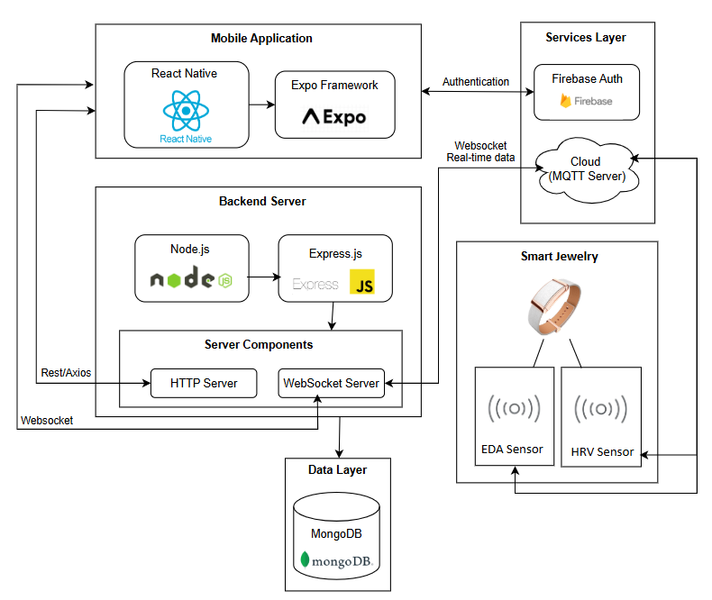

*fig 4. System Architecture diagram*

The system integrates a mobile application, backend server, and future cloud-based services. The mobile application, developed with React Native and Expo framework, communicates with a backend server powered by Node.js and Express.js. This server manages API requests through REST/Axios and maintains real-time communication via WebSocket. MongoDB is used for flexible and scalable data storage, while Firebase Authentication provides secure user management. In future implementations, cloud services (MQTT server) will handle data from wearable jewelry, enabling efficient IoT communication for sensor data collection and processing. The existing WebSocket infrastructure will facilitate real-time data transmission between these cloud services and the mobile application, ensuring seamless delivery of sensor updates to users.

# 4. Work Artifacts

# 4.1 Use Case Diagram

The Cozy Space system supports anxiety management through digital interventions. Patients can configure their profiles with personal details, notification preferences, and data sharing settings, while accessing features like breathing exercises and a relaxation chatbot. When anxiety alerts are triggered, patients can select calming actions for immediate support. The system incorporates the DASS-21 questionnaire for assessment, and patients can document their anxiety experiences through free-form notes, structured documentation, or recordings. Therapists can review patient documentation, access questionnaire analyses, and view statistics reports. Administrators manage key features and sensor data simulation, while ensuring secure user access through login functionality.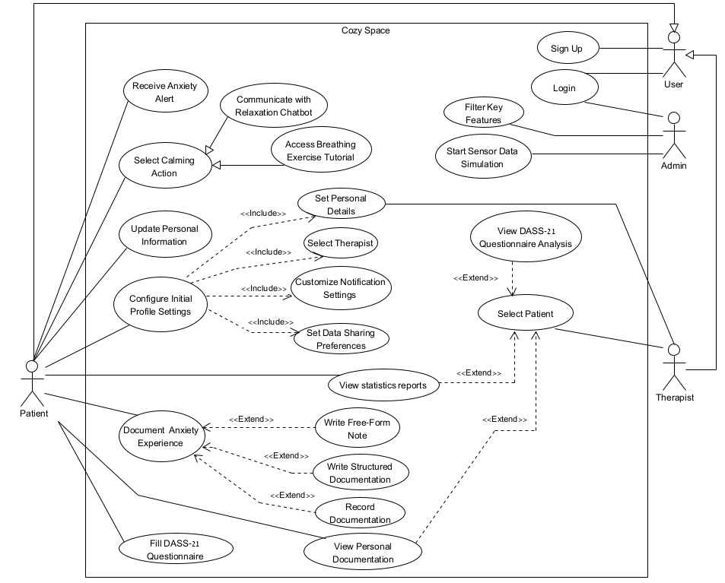

*fig 5. Use Case diagram*

# 4.2 Activity Diagram

# 4.2.1 Patient and the system

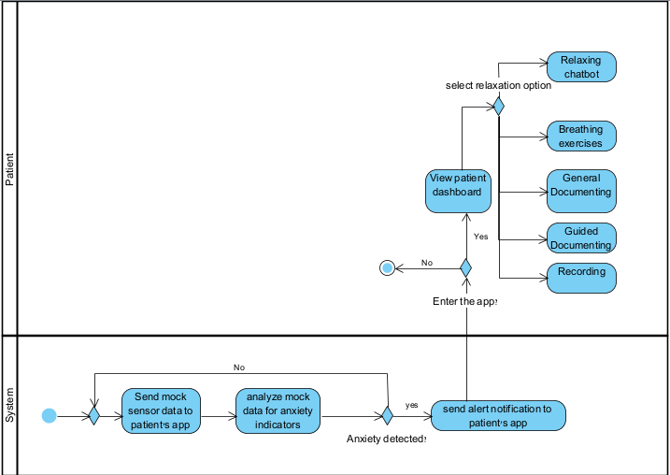

*fig 6. Activity diagram - Patient and the system*

# 4.2.2 Therapist and the system

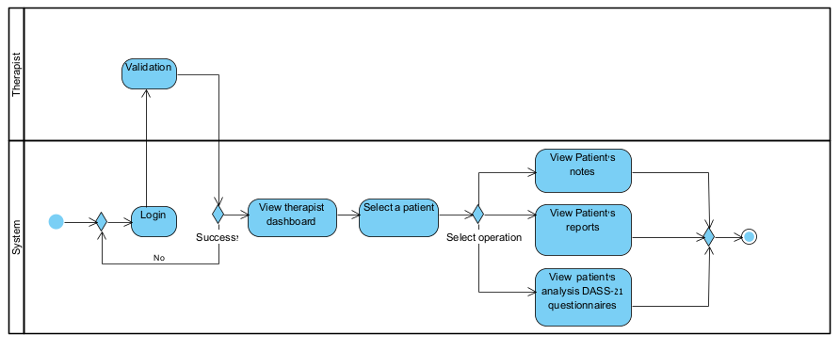

*fig 7. Activity diagram - Therapist and the system*

# 4.3 Working Flow Diagram

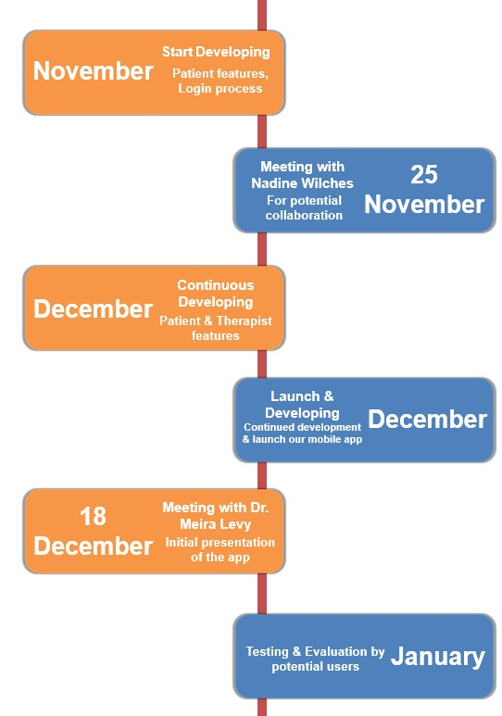

*fig 8. Working Flow Diagram*

In November, we began developing the app, focusing on key features, login and registration process. Throughout the project, we held weekly meetings with our advisor, and that month, we also met with Nadine Wilches to explore a potential collaboration. The goal of this meeting was to discuss integrating the questionnaire she designed into our app. This questionnaire, will be completed by users during registration, would provide insights into their mental state.

Key takeaways from our discussion with her included:

* The importance of an AI chat feature – This could support individuals facing long wait times for therapists, helping both before and after therapy.
* Diary functionality – She was particularly enthusiastic about this feature, seeing it as a valuable intake tool for therapists to better understand their patients.
* Integration options – The questionnaire could be provided via an external, anonymous link for personal use. Alternatively, an annual license could enable deeper integration, but we needed to determine if this was feasible at our current stage.

Ultimately, we decided not to proceed with the questionnaire due to its length, which could deter users, and the external link option, which did not align well with our app’s structure.

In December, we continued development, focusing on features for both therapists and patients. We successfully deployed the application and later met with Dr. Meira Levy, who provided valuable feedback. Dr. Levy, representing Shenkar College, is responsible for developing the smart jewelry intended to interface with our app. Her feedback was highly positive, and we are optimistic about future integration with the smart jewelry.

In January, we conducted testing and evaluation with various users, specifically individuals experiencing anxiety. Their feedback provided important insights into our app’s functionality and user experience.

## 5. Challenges & Solutions

* **Entering New Development Domain:** Having never developed a mobile application before, we initially faced significant uncertainty about project execution. We solved this by following a step-by-step learning approach - watching tutorials, studying development guides, and getting help during the initial app setup phase.
* **Cross-Platform Compatibility:** Developing a multi-platform application for both iOS and Android presented frequent compatibility challenges, especially since each of us had a different operating system. We addressed this through rigorous cross-platform testing after each feature implementation, coupled with detailed analysis of compatibility issues as they arose.
* **Hardware Unavailability:** Our project concept required a smart jewelry piece with sensors that would collect data continuously to monitor anxiety and alert users in real-time. Since we didn't have access to any physical hardware, we had to think of an alternative solution. We developed a simulation system that generated mock sensor data to replicate how the actual device would behave.
* **Anxiety Detection Implementation:** Due to the short timeframe and complexity of our multi-feature application, we decided not to implement machine learning for detecting anxiety accurately (which emerged from phase A of the project as a necessary factor for identifying anxiety in the most accurate way). Instead, we opted for a simpler solution for the feasibility of the project. We implemented a basic logic system that identifies sharp changes in anxiety-indicating metrics to trigger alerts, while designing it so that machine learning could be integrated in the future.
* **Reaching Potential Users**: A significant challenge we faced was accessing potential users for initial evaluation. This challenge began in phase A of the project when we tried to conduct interviews to gather relevant requirements from people dealing with anxiety who need a real-time management system. This challenge continued into phase B as well. Our solution was to distribute questionnaires through friends who could share them with people they know who experience anxiety. This approach-maintained anonymity, making it easier for people to respond to an anonymous questionnaire and install the application anonymously. The feedback we received from the therapists themselves was also very helpful, as they helped us understand better what works for patients.

# 6. Evaluation

Our evaluation process focused on assessing the Cozy Space Application's performance and usability through methodology: user testing.

To evaluate our application's effectiveness and real-world applicability, we conducted the main assessment approach: A System Usability Scale (SUS) survey administered to potential users following a demonstration of the system's functions.

# 6.1 SUS Survey

In January 2025, we surveyed 23 potential users to evaluate the system's usability. The survey used the standard System Usability Scale, a reliable tool for measuring system usability. Each question's results are presented below with a corresponding bar chart showing the distribution of responses on a scale from 1 (strongly disagree) to 5 (strongly agree):

1. **I would like to use this system frequently.**

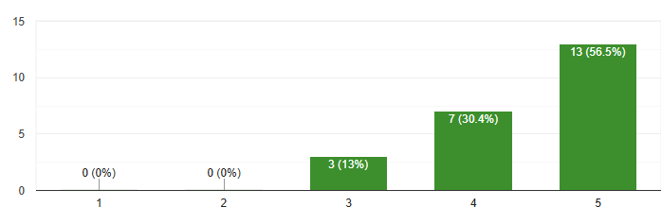

1. **I found the system unnecessarily complex.**

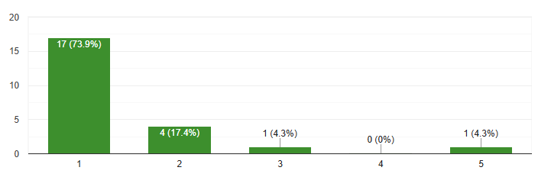

1. **I thought the system was easy to use.**

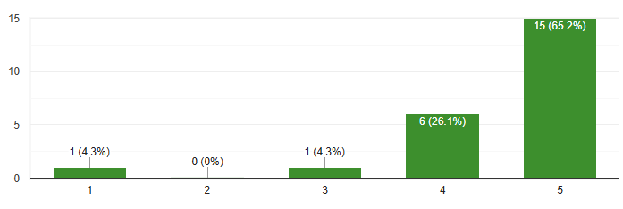

1. **I would need technical support to be able to use this system.**

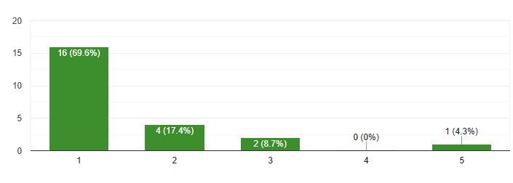

1. **I found that the various functions of the system were well integrated.**

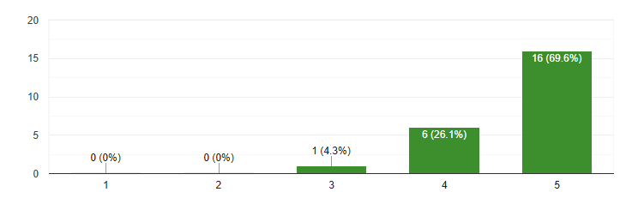

1. **I thought there was too much inconsistency in this system.**

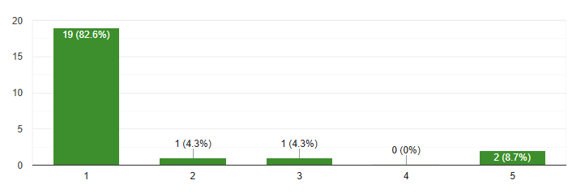

1. **I think most people would be able to learn to use this system easily.**

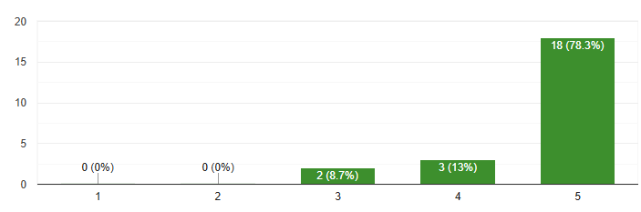

1. **I found the system very tough to use.**

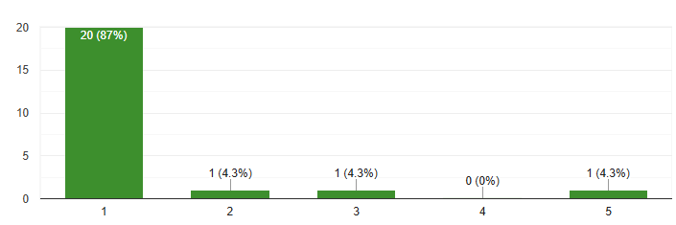

1. **I felt very confident when using the system.**

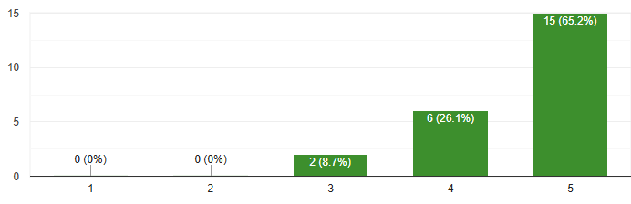

1. **I have to learn a lot of things before I can use this system.**

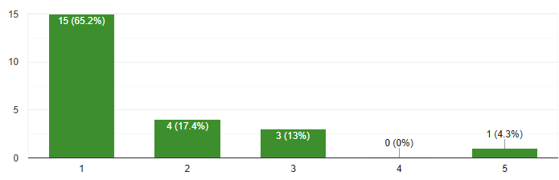

# 6.2 Evaluation Summary

The evaluation of the application yielded predominantly positive results, demonstrated by a high SUS score of **88.69565217**. In addition to the SUS questionnaire, users were asked to rate their anxiety levels on a scale of 1 to 10 (where 1 represents the lowest and 10 the highest anxiety level), with the average score among respondents being 5.1. Users particularly commended the intuitive interface design and essential features, including breathing exercises, calming chat functionality, and the ability to share personal information with therapists. They highlighted the convenience of the interface, the warm and calming color scheme, and the seamless navigation that contributed to an overall positive user experience. The ability to share personal information with therapists was perceived as a key advantage, as it allowed for better-informed treatment and enhanced therapist-patient communication. Additionally, users appreciated the app’s capacity to provide real-time support through its automated features, particularly when anxiety was detected, enabling immediate intervention.

While some users expressed interest in real-time communication with therapists, this feature was intentionally excluded during Phase A after interviews with mental health professionals revealed that therapist unavailability could potentially increase patient anxiety. Instead, the chatbot was designed as a primary real-time support mechanism. However, user feedback indicated that the chatbot responses could be improved to feel more natural, empathetic, and contextually relevant.

Looking toward future iterations, user feedback highlighted potential areas for enhancement, such as expanded design options, refined chat responses, and the implementation of gamification elements to enhance engagement. Specifically, users expressed a desire for a more visually appealing home screen design to create a welcoming and engaging first impression. Additionally, they emphasized the importance of implementing stricter verification protocols for therapist registration to ensure platform security, reinforcing trust and safety within the application.

## 7. Results and Conclusions

We were partially able to achieve the goals of our project. Our primary objective was to develop an application that could assist therapists and patients by identifying anxiety through physiological signs detected by a wearable smart piece of jewelry equipped with sensors. Although the jewelry and its associated sensors were not developed during the project timeline, we successfully implemented the application and integrated features designed to enhance the user experience for both therapists and patients.  
Our primary consideration was to ensure that the application would remain functional and relevant even as the hardware development progressed. We prioritized features that therapists identified as essential during our interviews, such as real-time notifications, patient monitoring tools, and data visualization. By aligning the application’s development with the needs of end-users, we ensured its utility irrespective of whether the physical sensors were available.   
Another key consideration was scalability and adaptability. We designed the application to easily integrate with the sensors once they become available, minimizing the need for extensive rework.  
In conclusion, while we could not achieve the complete vision of the project due to external constraints, we successfully laid a strong foundation by developing an application that can accommodate future hardware integration. This approach reflects our adaptability and focus on delivering a functional product that addresses the needs of therapists and patients.

## 7.1. Lessons learned

* **Systematic Approach:** We worked correctly by starting with an in-depth literature study on anxiety, analyzing existing applications, and conducting interviews with psychologists to define the requirements.
* **Thorough Preparation:** Before implementation, we researched relevant technologies and designed a clear architecture, ensuring a strong foundation for development.
* **Team Collaboration:** Excellent teamwork was maintained throughout the project. Tasks were divided effectively, and regular meetings helped track progress, identify improvements, and make necessary changes.
* **Focus on Features:** We prioritized understanding the essential features the application needed, ensuring alignment with user needs.
* **App Design and User Interface:** We could have spent more time refining the user interface and experience to ensure greater intuitiveness and smoother navigation for users, particularly those in distress.

## 7.2. Project metrics

We believe the Anxiety Management App represents a significant step forward in mental health support technology. By combining user-centric design with innovative features, we've developed a tool that has the potential to greatly enhance anxiety management for individuals and facilitate collaboration with their therapists.

The current state of the app is more than just a concept; it's a working prototype that can be immediately utilized by individuals seeking to manage their anxiety and by therapists looking to monitor and support their patients effectively.

This project not only contributes to the field of mental health technology but also lays the foundation for future advancements in anxiety management solutions.

## 8. User Guide

# 8.1 Introduction Page - welcome

* **Purpose:** This is the first screen you'll see when you open the Cozy Space app. It introduces you to the app's purpose: to be your personal companion for finding peace and comfort in your daily life.
* **Key Elements:**
  + **App Name:** "Cozy Space" is displayed prominently.
  + **Navigation:**
    - **"Next" button:** Tap to proceed through a brief onboarding process.
    - **"Skip" button:** Allows you to bypass the onboarding and access the app's main features directly.

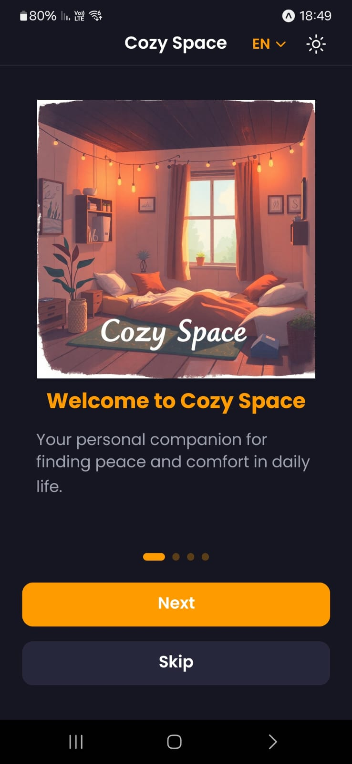

*fig 9. Introduction Page - welcome*

# 8.1.1 Introduction Page - Real Time Support

* **Purpose:** This screen highlights one of Cozy Space's core features: real-time access to guided breathing exercises and calming techniques.
* **Key Elements:**
  + **Feature Focus:** "Real-Time Support" clearly emphasizes the availability of immediate assistance.
  + **Navigation:**
    - **“Next" button:** Tap to proceed to the next onboarding screen.
    - **"Skip" button:** Allows you to skip the onboarding and access the app's main features directly.

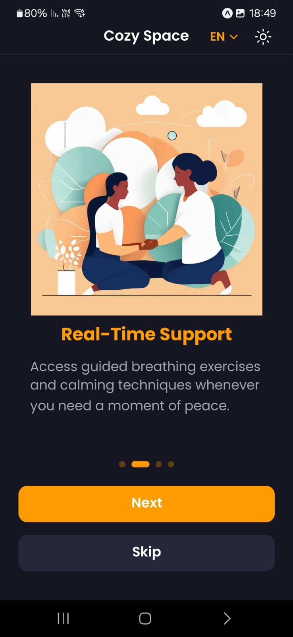

*fig 10. Introduction Page - Introduction Page - Real Time Support*

# 8.1.2 Introduction Page - Track Your Journey

* **Purpose:** This screen introduces the app's journaling and tracking features.
* **Key Elements:**
  + **Feature Focus:** "Track Your Journey" clearly emphasizes the app's ability to monitor and track progress.
  + **Navigation:**
    - **"Next" button:** Tap to proceed to the next onboarding screen or the main app interface.
    - **"Skip" button:** Allows you to skip the onboarding and access the app's main features directly.

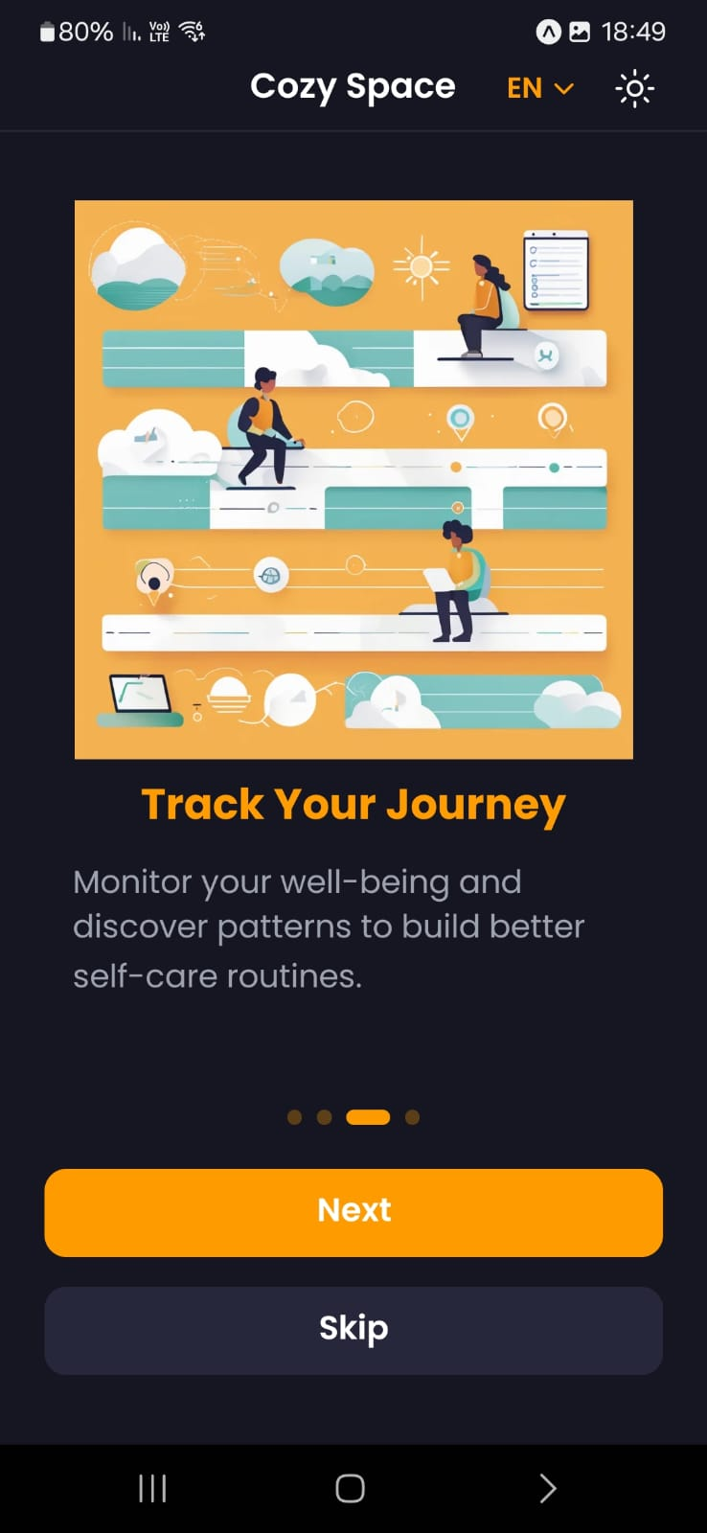

*fig 11. Introduction Page - Track Your Journey*

# 8.1.3 Introduction Page - Connect with Care

* **Purpose:** This screen introduces the app's feature for connecting with wellness professionals.
* **Key Elements:**
  + **Feature Focus:** "Connect with Care" clearly emphasizes the app's ability to facilitate communication with wellness professionals.
  + **Navigation:**
    - **"Get Started" button:** Tap to proceed to the next onboarding screen or the main app interface.
    - **"Skip" button:** Allows you to skip the onboarding and access the app's main features directly.

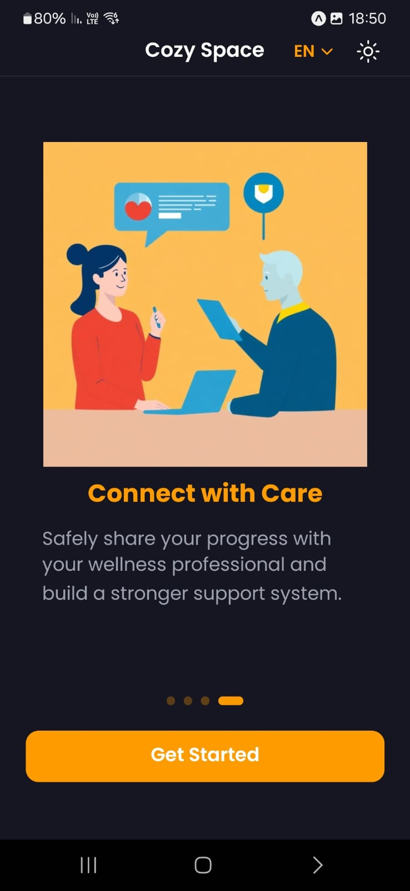

*fig 12. Introduction Page - Connect with Care*

# 8.2 Login Page

* **Purpose:** The login page is where users can access their accounts by providing their Email and Password.
* **Key Elements:**
  + **Input Fields:**
    - **"Email Address" field:** Users enter their registered email address.
    - **"Password" field:** Users enter their password for the app.
  + **Buttons:**
    - **"Sign In" button:** Tap to log in to the app**.**
    - **"Don't have an account? Sign Up" button:** Directs new users to the sign-up page if they don't have an account.
  + **Terms and Conditions:** "By continuing, you agree to our Terms of Service and Privacy Policy" reminds users of the app's terms and conditions.

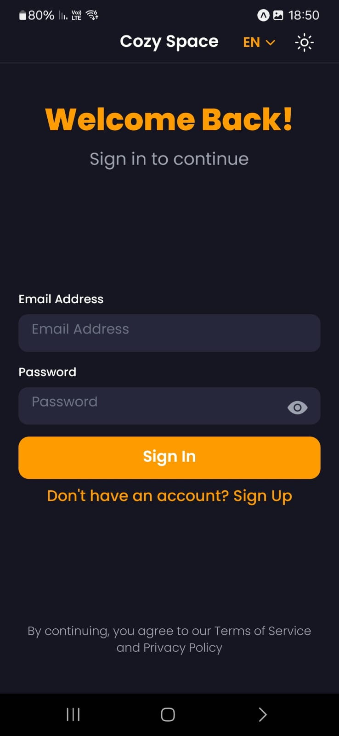

*fig 13. Login Page*

# 8.3 Sign Up Page

* **Purpose:** This screen is the sign-up page for new Cozy Space users.
* **Key Elements:**
  + **Input Fields:**
    - **"Email Address" field:** Users enter their email address.
    - **"Password" field:** Users create a password for the app.
    - **"Confirm Password" field:** Users re-enter their password to confirm accuracy.
  + **Button:**
    - **"Create Account" button:** Tap to create a new account and proceed to the app.
    - **Alternative Action:** "Already have an account? Sign In" provides a link for existing users to sign in.
  + **Terms and Conditions:** "By continuing, you agree to our Terms of Service and Privacy Policy" reminds users of the app's terms and conditions.

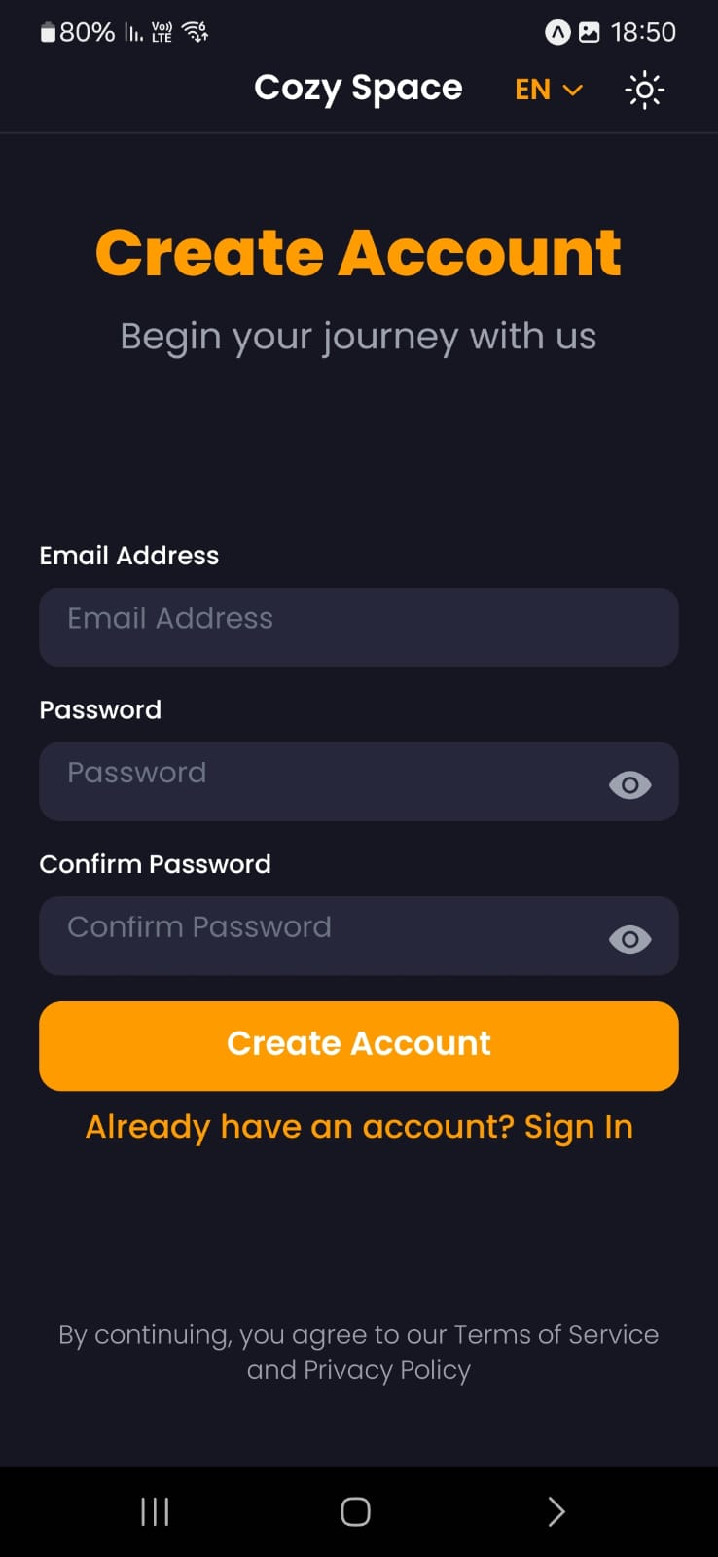

*fig 14. Sign Up Page*

# 8.4 Onboarding Page - Role Selection

* **Purpose:** This screen is the initial step in the Cozy Space onboarding process. It presents users with a choice of how they intend to use the app after creating their account.
* **Key Elements:**
* **Role Selection:** Users are presented with two options:
  + **"I'm Seeking Help":** This option is intended for individuals who want to use the app for personal well-being, such as tracking their mental health, accessing guided exercises, and connecting with therapists.
  + **"I'm a Therapist":** This option is for mental health professionals who want to use the app to support their patients, monitor progress, and maintain a professional relationship.

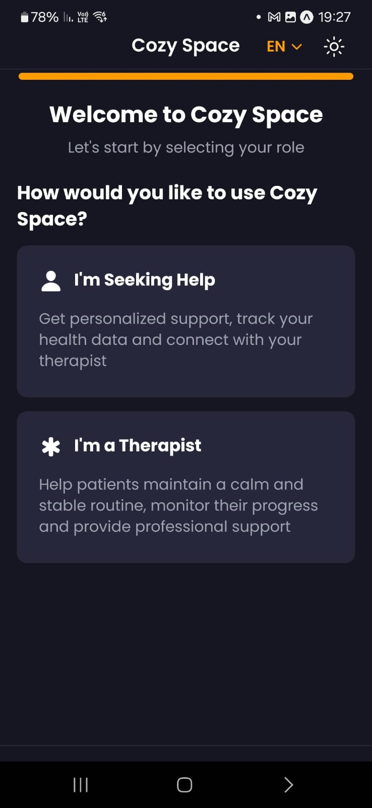

*fig 15. Onboarding Page - Role Selection*

# 8.5 Onboarding Page - Personal Information

* **Purpose:** This page aims to collect essential information about the user to personalize their app experience.
* **Elements:**
  + **Input Fields:**
    - **First Name:** Users enter their first name.
    - **Last Name:** Users enter their last name**.**
    - **Select Gender:** A dropdown menu or radio buttons allow users to select their gender (Male or Female).
  + **Navigation Buttons:**
    - **"Back" button:** Allows users to navigate back to the previous page ("Role Selection" page).
    - **"Continue" button:** Enables users to proceed to the next step in the onboarding process after entering their personal information.

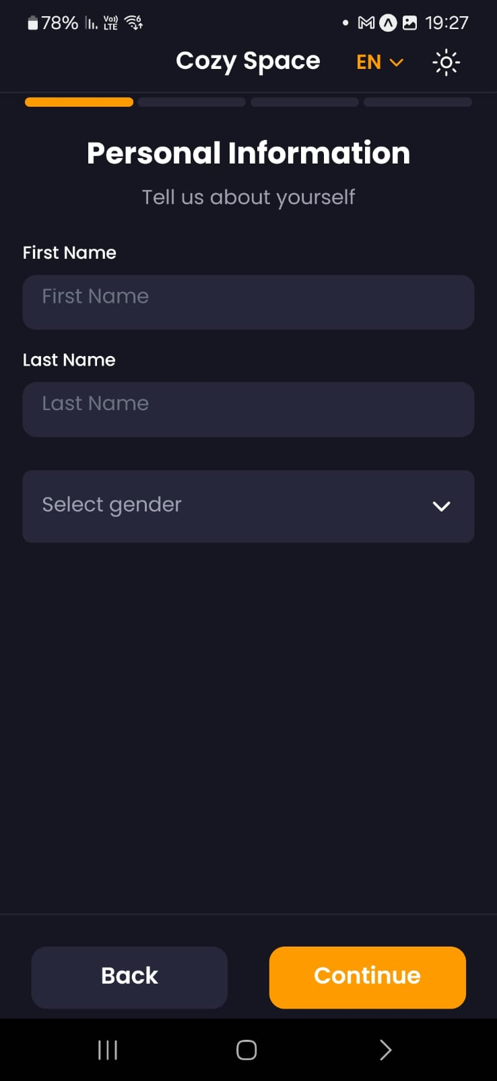

*fig 16. Onboarding Page - Personal Information*

# 8.6 Patient

# 8.6.1 Onboarding Page - Connect with a Therapist (initial)

* **Purpose:** Its primary purpose is to facilitate the connection between users and therapists within the app.
* **Key Elements:**
  + **Therapist Selection:**
    - **"Choose a therapist to work with" dropdown menu:** This is the central element of the page, allowing users to browse and select a therapist from a list.
  + **Navigation Buttons:**
    - **"Back" button:** Allows users to navigate back to the previous page ("Personal Information" page).
    - **"Continue" button:** Enables users to proceed to the next step, which would likely involve setting sharing preferences with the chosen therapist.

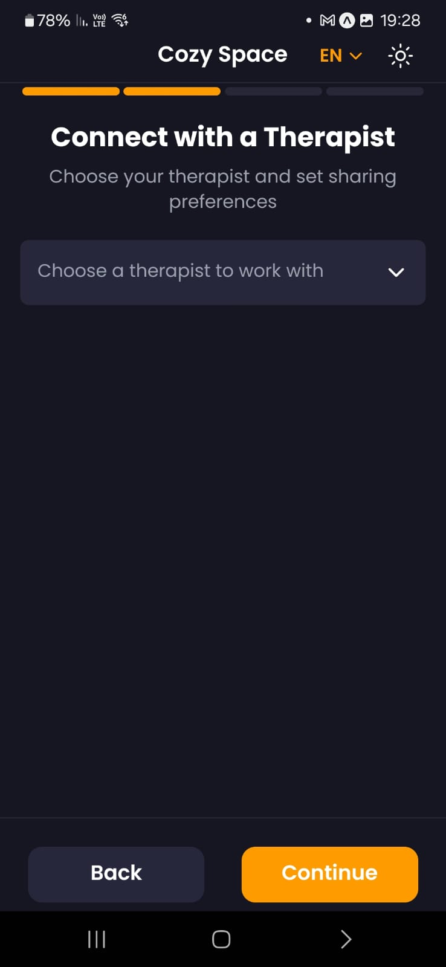

*fig 17. Onboarding Page - Connect with a Therapist (initial)*

# 8.6.2 Onboarding Page - Connect with a Therapist (after choosing)

* **Purpose:** This page allows users who have selected a therapist to define which data they are willing to share with that therapist within the app. This ensures user control and transparency regarding data sharing.
* **Key Elements:**
* **Therapist Selection (Top):**
  + "Dr. XXXX" is displayed.
  + A dropdown arrow next to the therapist's name might allow users to change their selection if needed.
* **Data Sharing Options:**
* **"Monitor your health data including graphs and statistics":** This checkbox allows users to share data visualizations of their health information.
* **"Personal Documentation":** This checkbox allows users to share personal notes they have created within the app.
* **Data Privacy Statement:** "Your therapist will only see the data you choose to share. You can change these settings at any time." This reassures users about their control over data sharing.
* **Navigation Buttons:**
  + **"Back" button:** Allows users to return to the previous page ("Therapist Selection" page).
  + **"Continue" button:** Enables users to proceed to the next step in the onboarding process, which might involve setting up communication preferences or accessing the app's main features.

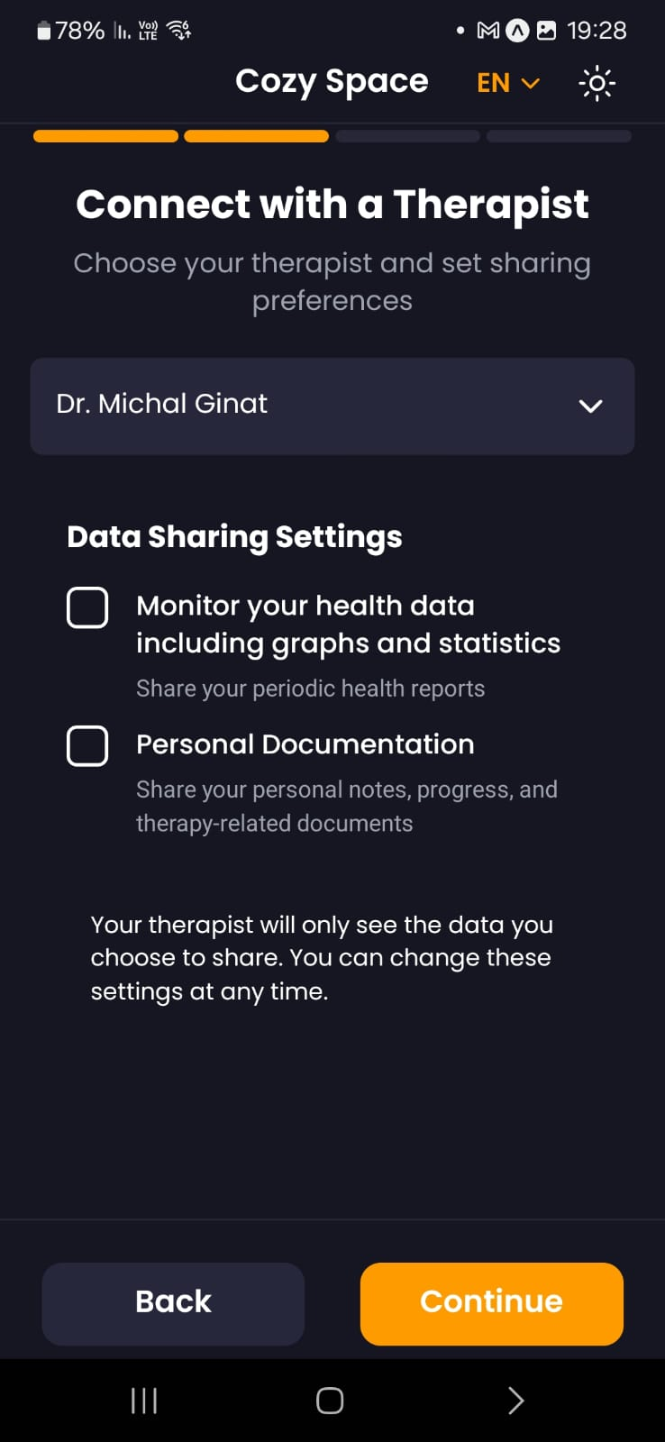

*fig 18. Onboarding Page - Connect with a Therapist (after choosing)*

# 8.6.3 Onboarding Page - Customize Your Experience

* **Purpose:** This page allows users to enable or disable optional features that enhance the app experience, particularly in managing stress and anxiety.
* **Key Elements:**
* **Feature Toggles:**
* **Smart Jewelry Integration:**
  + **"Enable Smart Jewelry" checkbox:** Allows users to connect and utilize smart jewelry devices with the Cozy Space app for enhanced stress monitoring and management.
* **Music Therapy:**
  + **"Enable Music Therapy" checkbox:** Allows users to access and utilize calming music within the app as a stress management tool.
* **Navigation Buttons:**
  + **"Back" button:** Allows users to navigate back to the previous page (likely the "Data Sharing Settings" page).
  + **"Continue" button:** Enables users to proceed to the next step in the onboarding process or to the main app interface.

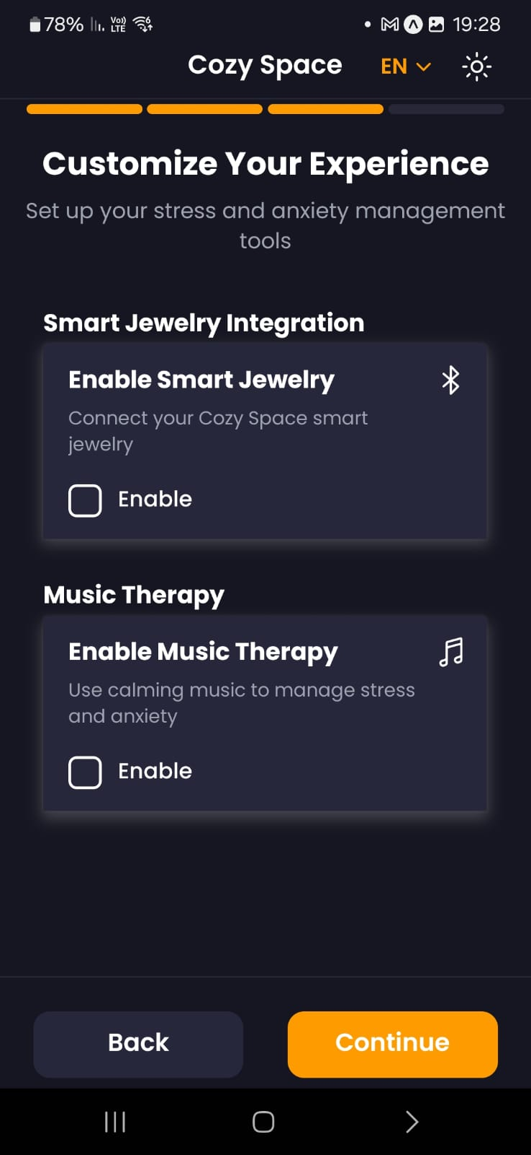

*fig 19. Onboarding Page - Customize Your Experience*

# 8.6.4 Onboarding Page - Onboarding Complete

* **Purpose:** This is the final page in the Cozy Space onboarding process. It serves as a confirmation and welcome message to the user, summarizing the setup process and highlighting the available features.
* **Key Elements:**
* **Headline:** "You're All Set!" conveys a sense of accomplishment and readiness.
* **Subheading:** "Let's start managing your health together" establishes a collaborative tone and reinforces the app's purpose.
* **Confirmation Message:** "Your profile has been set up successfully. You're ready to start managing your health optimally with professional support." provides a clear summary of the setup process and reassures the user that they are ready to use the app.
* **Available Features Summary:**
  + A list with checkmarks next to each enabled feature (Real-time physical data monitoring, Access to periodic health reports, Tools for managing a calm and stable routine, Professional support and healthcare provider sharing) visually confirms the user's selected settings.
* **Navigation Buttons:**
  + **“Back" button:** Allows users to review previous settings or make changes before proceeding.
  + **"Complete" button:** Enables users to finish the onboarding process and access the main app interface.

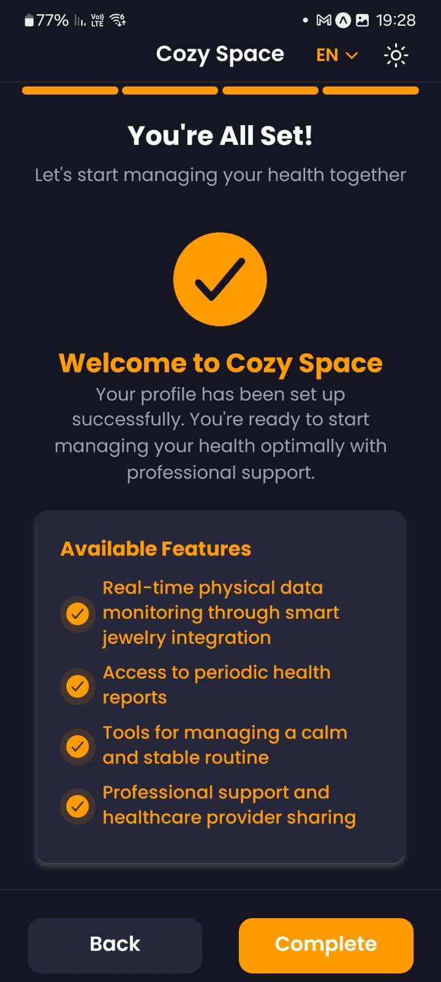

*fig 20. Onboarding Page - Onboarding Complete*

# 8.6.5 Monthly Mental Health Assessment Page

* **Purpose:**
  + **Baseline Assessment:** This initial assessment serves as a baseline for tracking the user's mental health over time.
  + **Personalized Insights:** The collected data will likely be used to generate personalized insights and recommendations for the user within the app.
  + **Ongoing Monitoring:** As the user continues to use the app, they will likely be presented with this assessment monthly to track changes in their mental well-being.
* **Key Elements:**
  + **Instructions: "Please rate how much each statement applied to you over the past week:"** provides clear guidance on how to respond to the questions.
  + **Likert Scale:** A 4-point Likert scale (0-3) is used for each statement, allowing users to express the degree to which each statement applies to them.
  + **Statements:** The assessment includes 20 statements related to different aspects of mental health, such as mood, anxiety, sleep, and overall well-being.

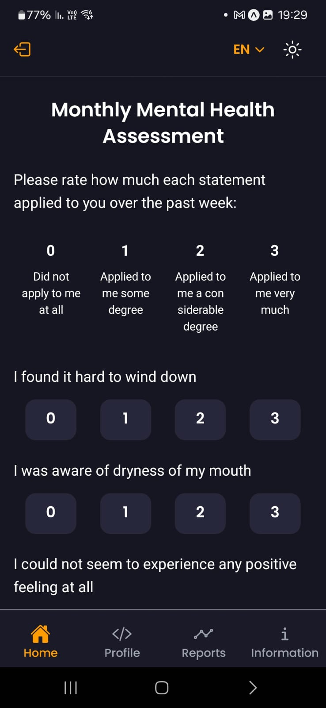

*fig 21. Monthly Mental Health Assessment Page*

# 8.6.6 Navigation Top bar (Logged in state)

* **Purpose:** The navigation bar offers back navigation, language selection, and theme toggling for a seamless user experience.
* **Key Elements:**
  + **Logout Button:** Clicking this will log the user out of the app.
  + **Language Selection (EN):** Allows the user to switch between languages.
  + **Theme Toggle Button:** Allows users to switch between light and dark modes for a personalized and visually comfortable experience.

# 8.6.7 Navigation Button bar (Logged in state)

* **Purpose:** The navigation bar offers a seamless user experience.
* **Key Elements:**
  + **"Home" button:** Takes the user to the main app screen.
  + **"Profile" button:** Accesses the user's profile and settings.
  + **"Reports" button:** Allows users to view reports and insights generated from their data.
  + **"Information" button:** Allows users to view their notes and recordings.

# 8.6.8 Home Page

* **Purpose:** This screen serves as the home screen for the logged-in user, providing quick access to key features and functionalities within the app.
* **Key Elements:** 
  + **Action Buttons:**
    - **"Talk to your personal assistant"**: Initiates a conversation with the app's AI assistant for guidance and support.
    - **"Guided Documenting"**: Launches a guided process for documenting thoughts, feelings, and experiences.
    - **"Document Now"**: Provides a direct option to start documenting without any guided prompts.
    - **"Breathing Exercises"**: Starts a guided breathing exercise session for relaxation and stress management.
    - **Recording Button:** The large red circle acts as a prominent button to start recording for documentation purposes.

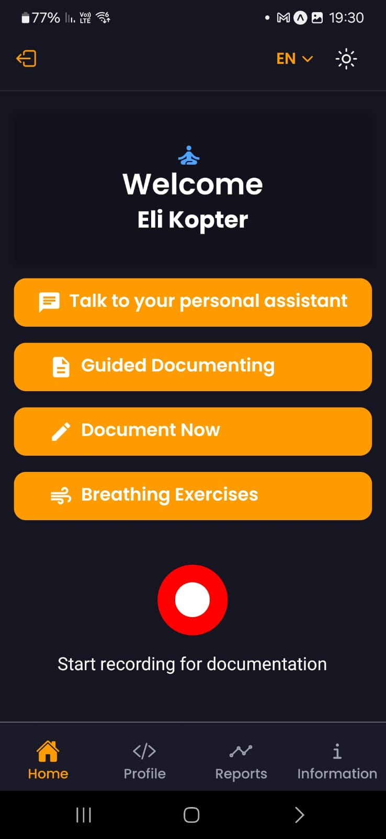

*fig 22. Home Page*

# 8.6.9 AI Chat page

* **Purpose:** This screen is the primary interface for interacting with Coral Care's chatbot. It provides a platform for users to communicate with the chatbot, ask questions, seek guidance, and receive support.
* **Key Elements:**
  + **Input Field:** "Type your message..." provides a space for the user to enter their text messages.
  + **Send Button:** The arrow icon functions as the send button to submit the user's message to the chatbot.
  + **Attachment Icons:**
  + **"+" button:** Allows the user to change chatbot messages.
  + **"Clock" icon:** Allows the user to view the conversation history, showing both user messages and chatbot responses.

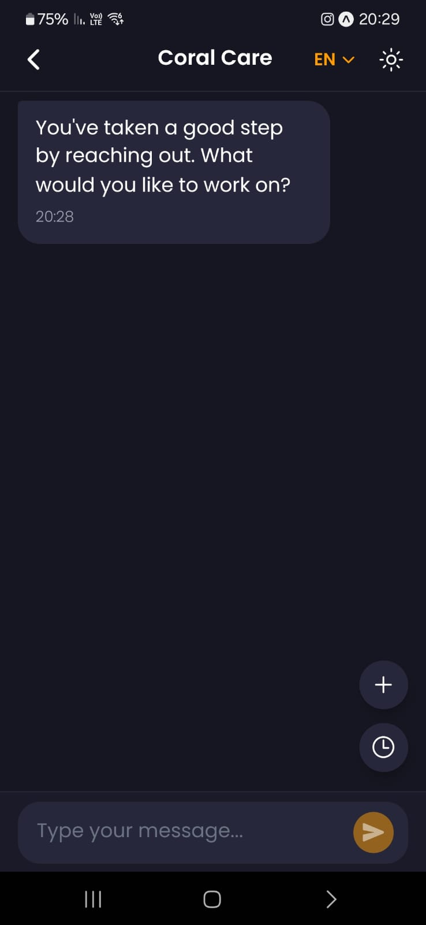

*fig 23. AI Chat page*

# 8.6.10 Guided Documenting Page

* **Purpose:** This screen guides users through a structured process of documenting their current anxiety levels and experiences. By providing a series of guided questions and prompts, the screen encourages introspection, helps users gather relevant information, and facilitates a deeper understanding of their anxiety patterns.
* **Key Elements:**
  + **Anxiety Level Rating:**
    - "How would you rate your current anxiety level?" presents users with a slider or scale (0-10) to visually rate their current anxiety level.
    - The slider displays the current rating with a corresponding descriptive label (e.g., "5 - Moderate Anxiety").
  + **Free-Text Fields - 6 guided questions**

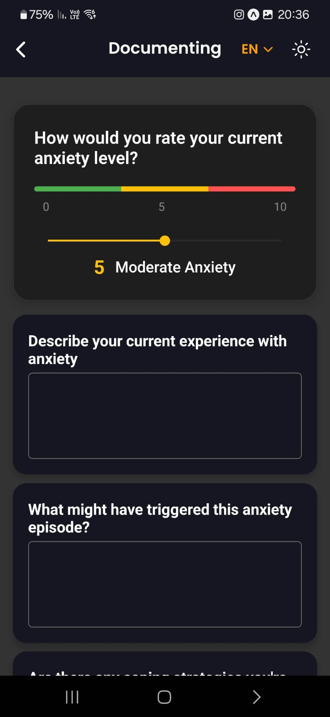

*fig 24. Guided Documenting Page*

# 8.6.11 Direct Documenting Page

* **Purpose:** This screen appears as part of the documentation feature. It allows users to freely express their thoughts and feelings in a journal-like format.
* **Key Elements:**
  + **Text Editor:**
    - “Write your thoughts here..." presents a large text field with multiple lines, encouraging users to write freely and expansively.
  + **"Add Note" Button:** This prominent button prompts the user to save the written entry.

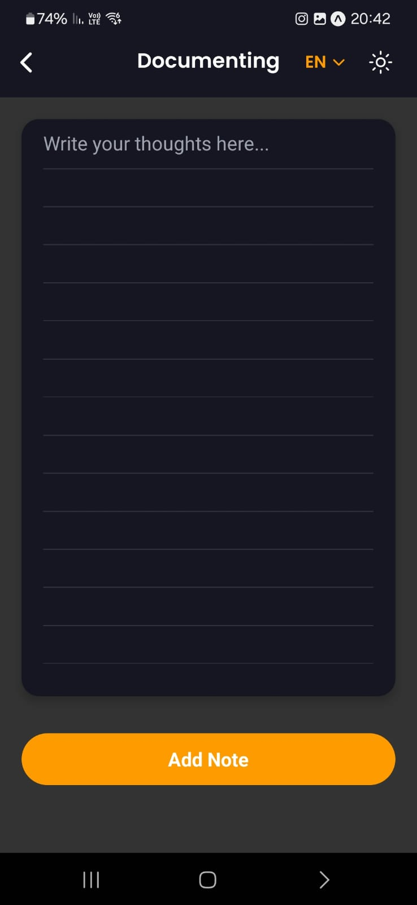

*fig 25. Direct Documenting Page*

# 8.6.12 Breathing Exercises Page

* **Purpose:** This screen is the starting point for a guided breathing exercise. It aims to guide users through a breathing exercise to help them relax and manage stress.
* **Key Elements:**
  + **Progress Bar:** It fills up gradually as the user does the exercise.
  + **Circular Timer:** Initially, the circular timer displays "Ready?" prompting the user to prepare for the exercise. Once the "Start" button is pressed, the timer likely transitions to a dynamic state, visually guiding the user through the inhale, hold, and exhale phases of the breathing pattern.
  + **Breathing Pattern:** Indicates the suggested breathing pattern (4-4-4 or 4-7-8).
  + **Guidance:** The "Guidance" icon provides access to instructions and explanations about the breathing technique.
  + **Timer:** Represents the timer for the current breathing session, which will start counting once the exercise begins.
  + **"Start" Button:** The prominent orange button initiates the guided breathing exercise.

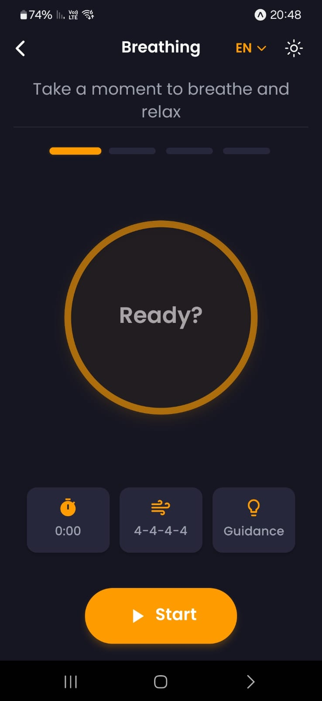

*fig 26. Breathing Exercises Page*

# 8.6.13 Profile Page

* **Purpose:** This screen is the user's profile page. It allows users to view and manage their personal information, data sharing settings, and app preferences.
* **Key Elements:**
* **Personal Information:**
  + Displays the user's full name, email address, and gender.
* **Therapist Selection:**
  + "Choose a therapist to work with" dropdown menu: Shows the currently selected therapist.
* **Data Sharing Settings:**
  + "Monitor your health data including graphs and statistics" (check box): Indicates that the user has enabled the sharing of health data visualizations and summaries with their therapist.
  + "Personal Documentation" (check box): Indicates that the user has enabled the sharing of personal notes with their therapist.
* A privacy statement reassures the user that only the selected data will be shared and that these settings can be changed at any time.
* **Preferences:**
* **Smart Jewelry Integration:**
  + "Enable Smart Jewelry" checkbox: Indicates that the user has enabled the integration of smart jewelry devices with the app.
  + "Connect your Cozy Space smart jewelry" button: Allows the user to connect their smart jewelry device to the app.
* **Music Therapy:**
  + "Enable Music Therapy" checkbox: Indicates that the user has enabled the use of calming music within the app for stress management.
  + "Use calming music to manage stress and anxiety" provides a brief description of the feature.
* **"Save Changes" Button:** Allows users to save any modifications made to their profile, data sharing settings, or preferences.

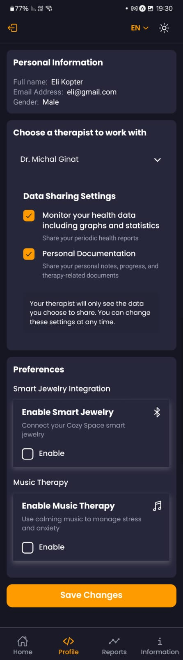 - Scroll view screen

*fig 27. Profile Page*

# 8.6.14 Reports Page

* **Purpose:** This screen displays a summary of the user's activity and progress within the app over a selected date range. It provides key metrics and visualizations related to the user's anxiety levels, journaling activities, and breathing exercises.
* **Key Elements:**
  + **Date Range:**
    - Displays the current date range for the report.
    - "Edit" button allows the user to customize the date range for the report.
* **Key Metrics:**
  + **Average Anxiety Intensity:** Displays the average anxiety level reported by the user during the selected period.
  + **Average Episode Duration:** Displays the average duration of anxiety episodes reported by the user.
  + **Notes Created:** Displays the total number of journal entries created by the user during the selected period.
  + **Anxiety Events:** Displays the total number of anxiety events the user had during the selected period.
  + **Breathing Sessions:** Displays the total number of breathing sessions completed by the user during the selected period.
  + **Avg. Breathing Session Duration:** Displays the average duration of breathing sessions conducted by the user.
* **Anxiety Events Chart:**
  + A line chart visually represents the number of anxiety events recorded each day of the week.
  + This visual representation provides a quick overview of the user's anxiety trends over time.

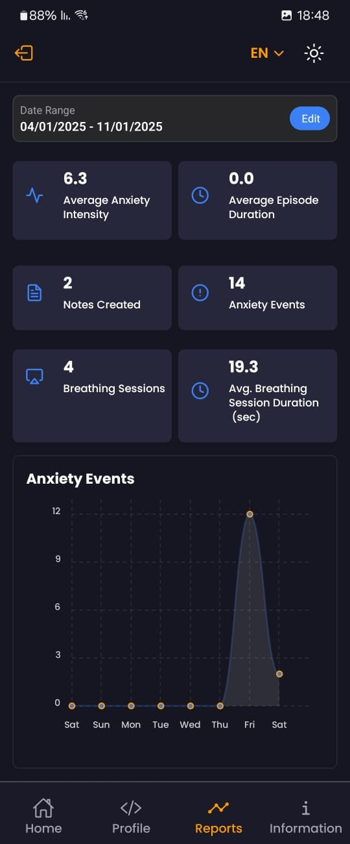

*fig 28. Reports Page*

# 8.6.15 Information Page

* **Purpose:** This screen is a section within the user's profile. It provides access to various types of user-generated data, including notes, recordings, and sensor data.
* **Key Elements:**
  + **Notes:** A button with a list icon that takes the user to a list of their notes created within the app.
  + **Recordings:** A button with a microphone icon that takes the user to a list of audio recordings made within the app.
  + **Sensor Data:** Displaying receiving data from “connected sensors”. This section displays data collected from wearable devices or other sensors if integrated with the app (HRV, EDA).

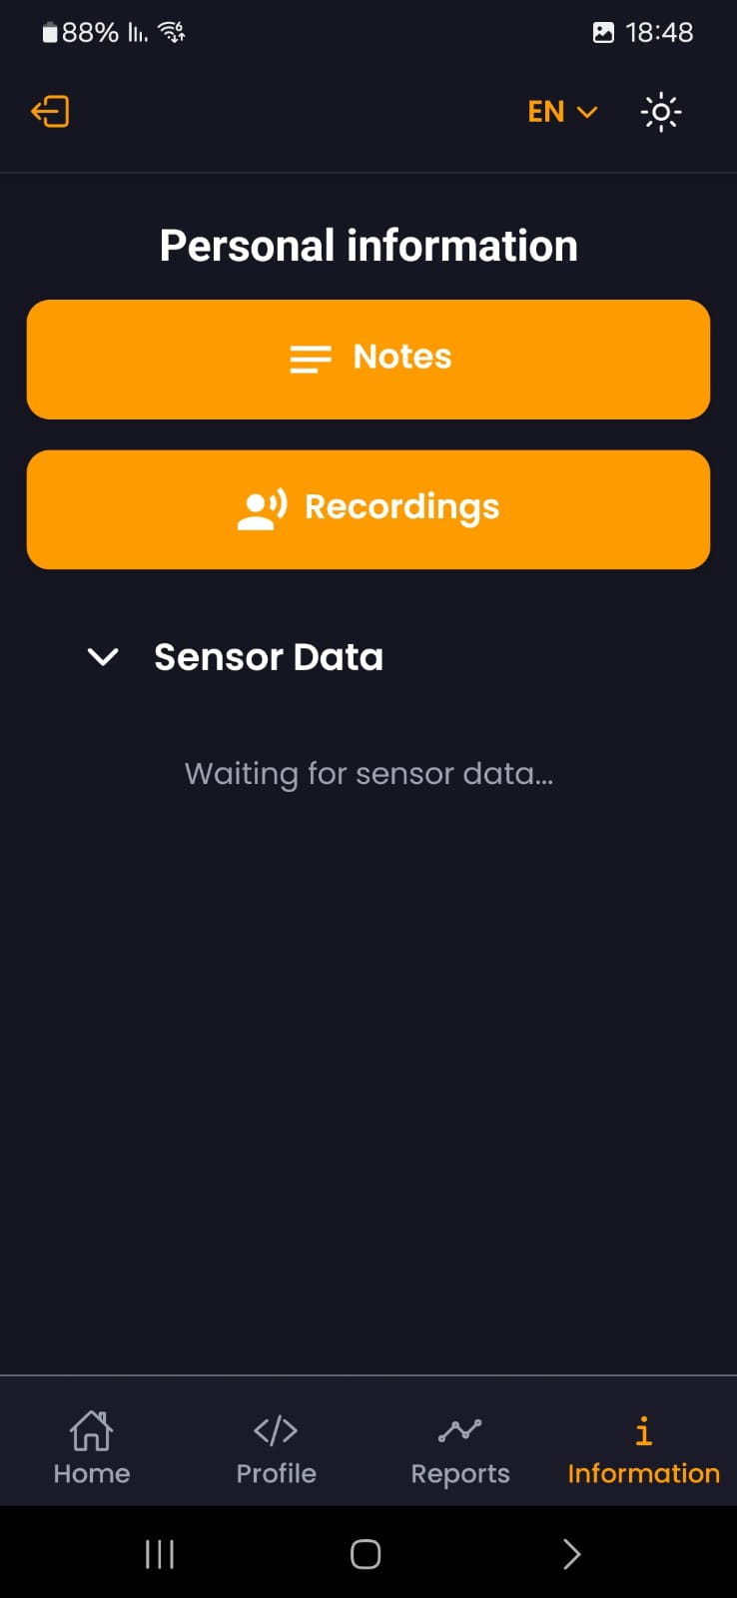

*fig 29. Information Page*

# 8.6.16 Notes Screen

* **Purpose:** This screen displays a list of notes created by the user within the app. It allows users to easily access and review their previous entries.
* **Key Elements:**

Displays a list of recent notes with the following information for each entry:

* Date and Time: Shows the date and time when the entry was created.
* Short Preview: Displays a brief preview of the entry's content.

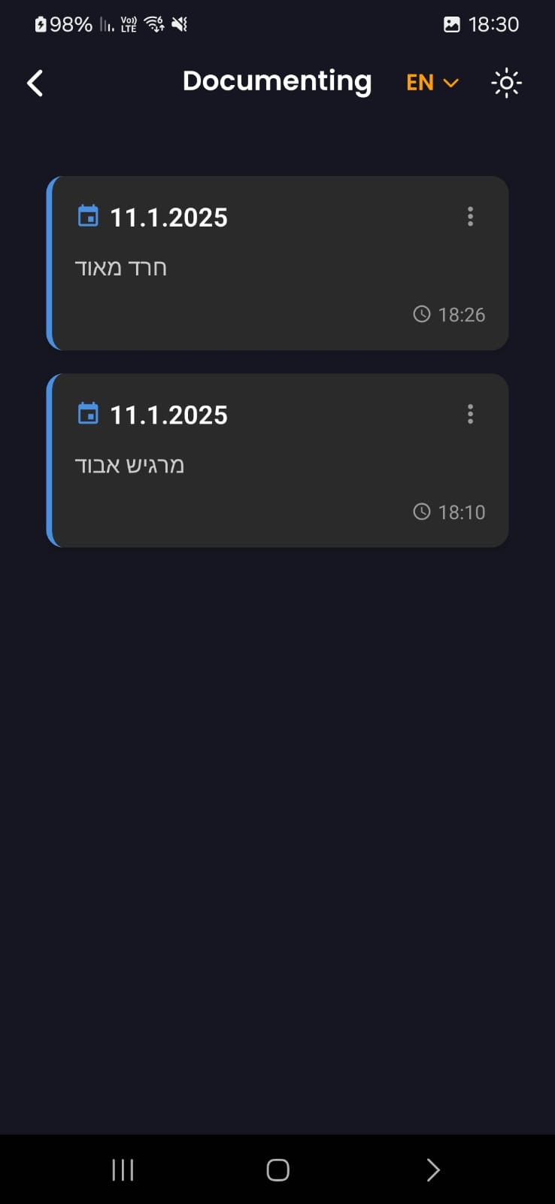

*fig 30. Notes Screen*

# 8.6.17 Edit Notes Screen

* **Purpose:** This screen displays the content of a selected note, allowing users to view, edit, or delete it.
* **Key Elements:**
  + **Entry Content:**
    - The main portion of the screen displays the full text of the selected journal entry.
  + **Action Buttons:**
    - **"Cancel" button:** Allows users to discard any changes made to the entry and return to the view-only mode.
    - **"Save" button:** Saves any edits made to the entry.
    - **"Delete" button:** Permanently deletes the selected journal entry.

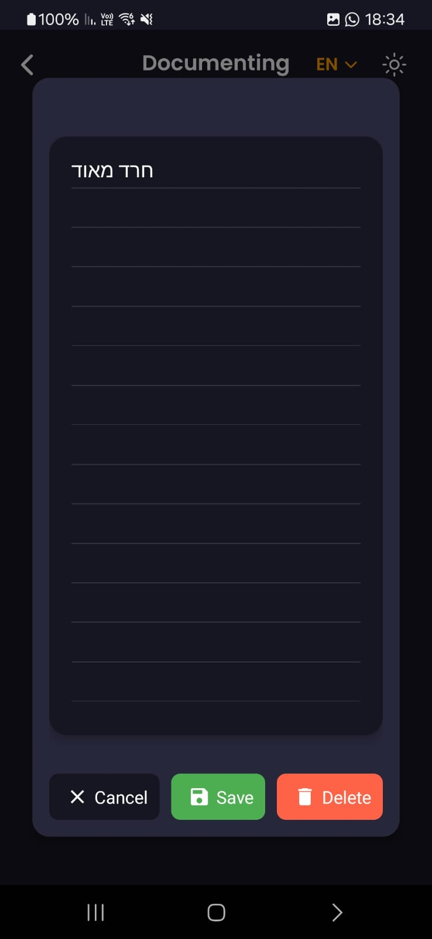

*fig 31. Edit Notes Screen*

# 8.6.18 Recordings Screen

* **Purpose:** This screen displays a list of audios made by the user within the app. It allows users to access and listen to their recordings.
* **Key Elements:**
  + **List of Recordings:** Displays a list of recordings with the following information for each recording:
    - Date and Time: Shows the date and time when the recording was created.
  + **Audio Playback:** When a user taps on a recording in the list, the app will initiate playback of the selected recording.

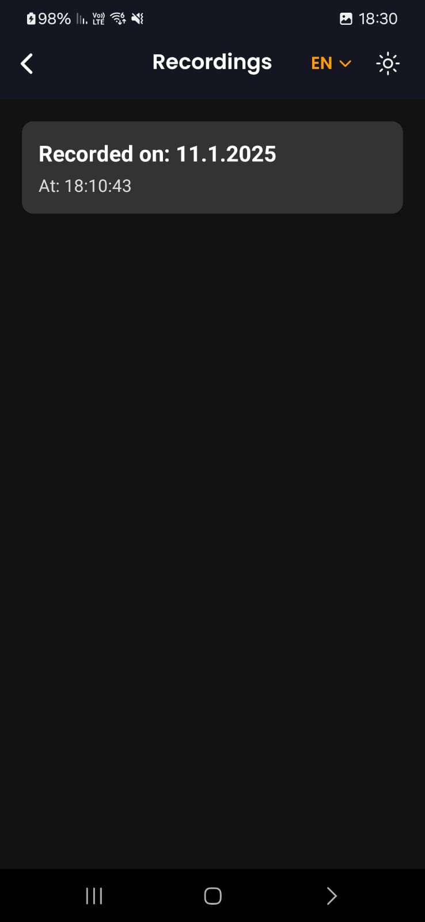

*fig 32. Recordings Screen*

# 8.7 Therapist

# 8.7.1 Professional Background Page

* **Purpose:** This screen is part of the sign-up process specifically for therapists using the app. Its purpose is to collect essential professional information about the therapist to ensure proper credentialing, verification, and potentially match them with suitable clients.
* **Key Elements:**
  + **Educational Background:**
    - "Select your education level" dropdown menu: Allows therapists to select their highest level of education.
  + **Years of Experience:**
    - "Select your experience level" dropdown menu: Allows therapists to select their years of professional experience.
  + **Current Workplace:**
    - "e.g., Private Practice, Hospital Name" provides an example and prompts therapists to enter their current place of employment (e.g., clinic name, hospital name).
  + **Primary Specialization:**
    - "Select your specialization" dropdown menu: Allows therapists to select their primary area of specialization.
  + **Professional License Number:**
    - "Enter your license number" field: Requires therapists to enter their professional license number for verification and compliance.

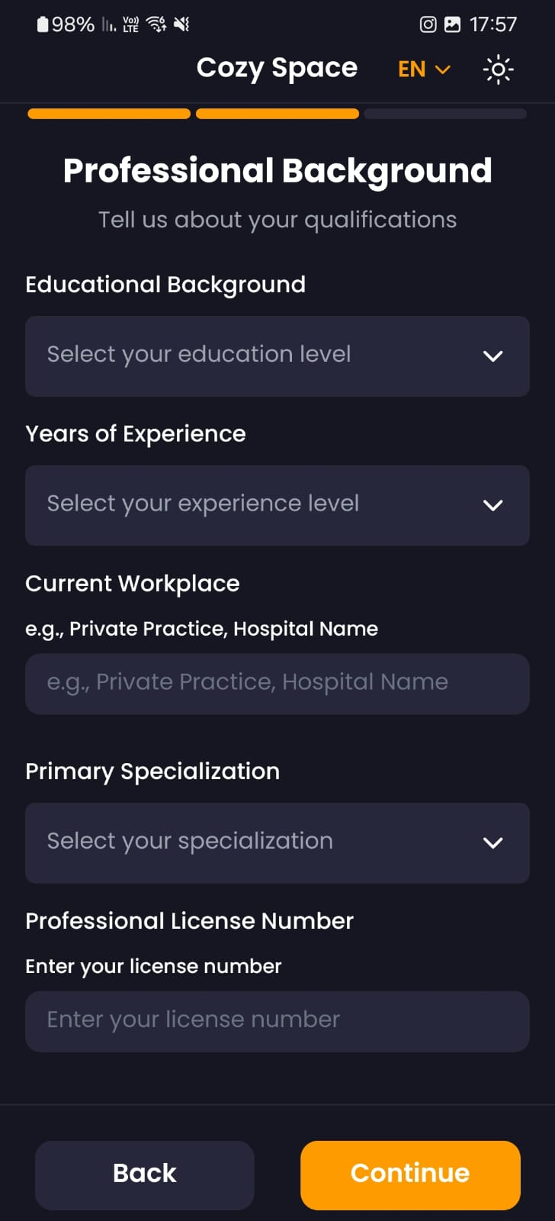

*fig 32. Professional Background Page*

# 8.7.2 Onboarding Page - Onboarding Complete

* **Purpose:** This screen marks the successful completion of the onboarding sign-up process for therapists within the app. It welcomes new therapists and highlights the key features available to them within the professional network.
* **Key Elements:**
  + **Success Message:** Congratulates the therapist on completing the onboarding process and emphasizes their role in supporting patients.
* **Available Features:**
  + A list with checkmarks next to each available feature:
    - "Access to patient anxiety tracking": Indicates that therapists can view patient data and track their progress.
    - "Secure communication platform": Highlights the availability of a secure platform for communication with patients.
    - "Professional dashboard": Indicates the availability of a dashboard with tools and insights relevant to therapists.
    - "Patient management tools": Suggests the availability of tools to manage patient schedules, appointments, and other administrative tasks.

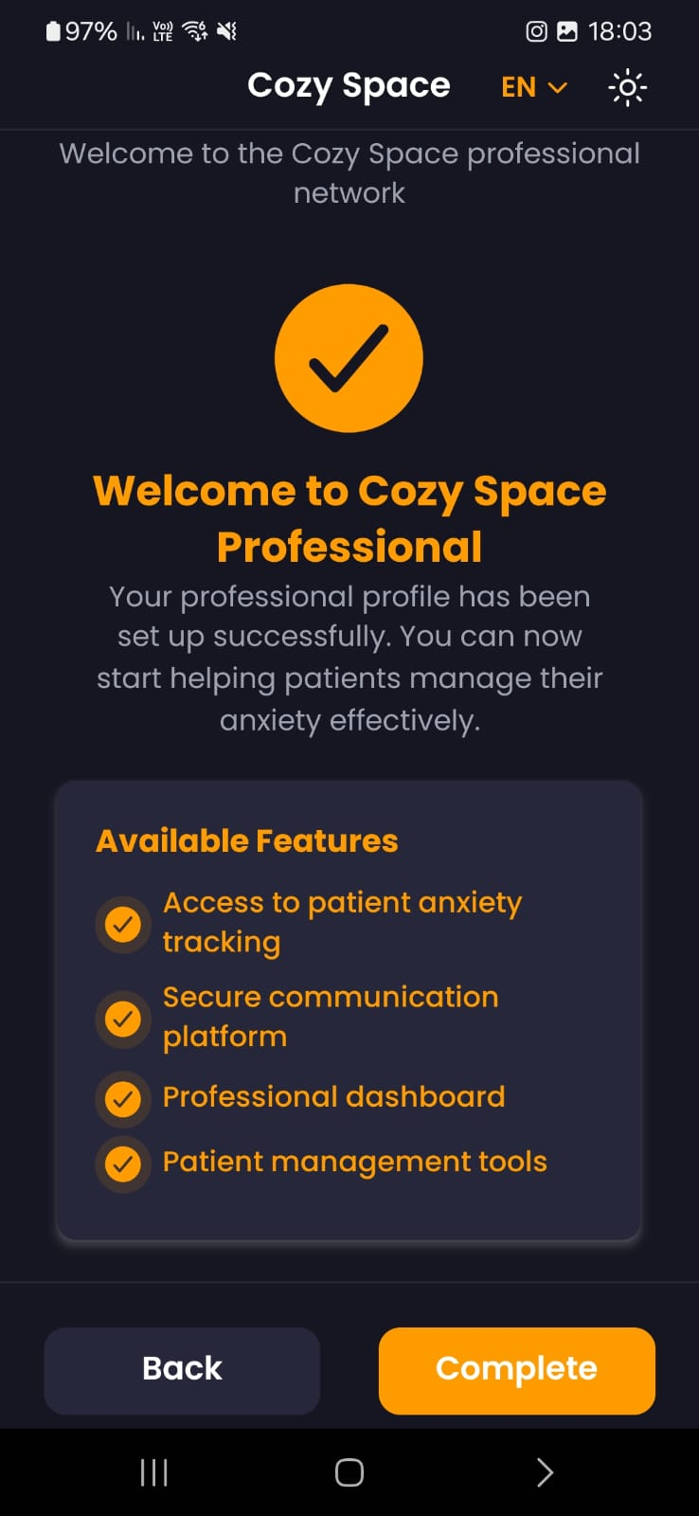

*fig 33. Onboarding Page - Onboarding Complete*

# 8.7.3 Home Page

* **Purpose:** This screen is the main dashboard for therapists within the app. It provides a starting point for therapists to access patient information and manage their professional activities.
* **Key Elements:**
  + **Patient Selection:**
    - The dropdown menu allows the therapist to select a patient from a list.

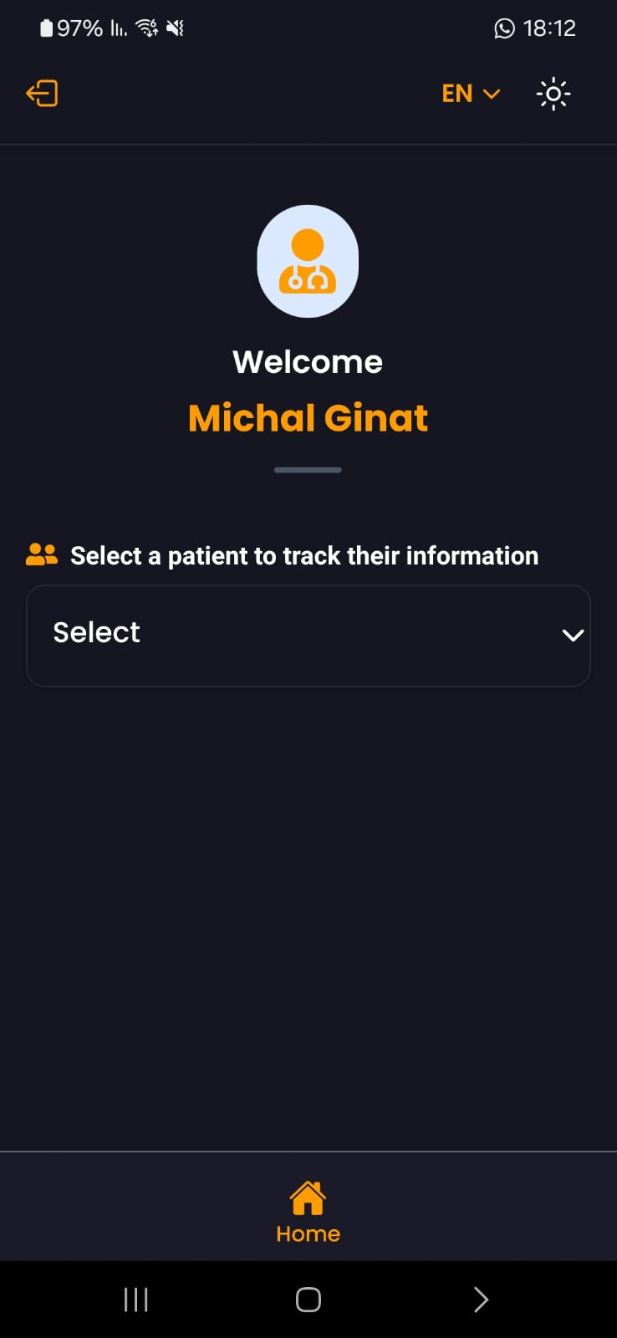

*fig 34. Home Page*

# 8.7.4 Patient’s information Page

* **Purpose:** This screen displays a dashboard view dedicated to the selected patient. It provides quick access to key information, tools, and features related to this specific patient's care within the app.
* **Key Elements:**
  + **Quick Action Buttons:**
    - **"Patient Notes":** Takes the therapist to a section where they can view notes related to the selected patient. (8.6.16)
    - **"Patient Reports":** Takes the therapist to a section where they can access reports and analytics specific to the patient's progress and well-being. (8.6.14)
    - **"Analysis of DASS-21 questionnaires":** Takes the therapist to an analysis of their responses to the DASS-21 questionnaire.

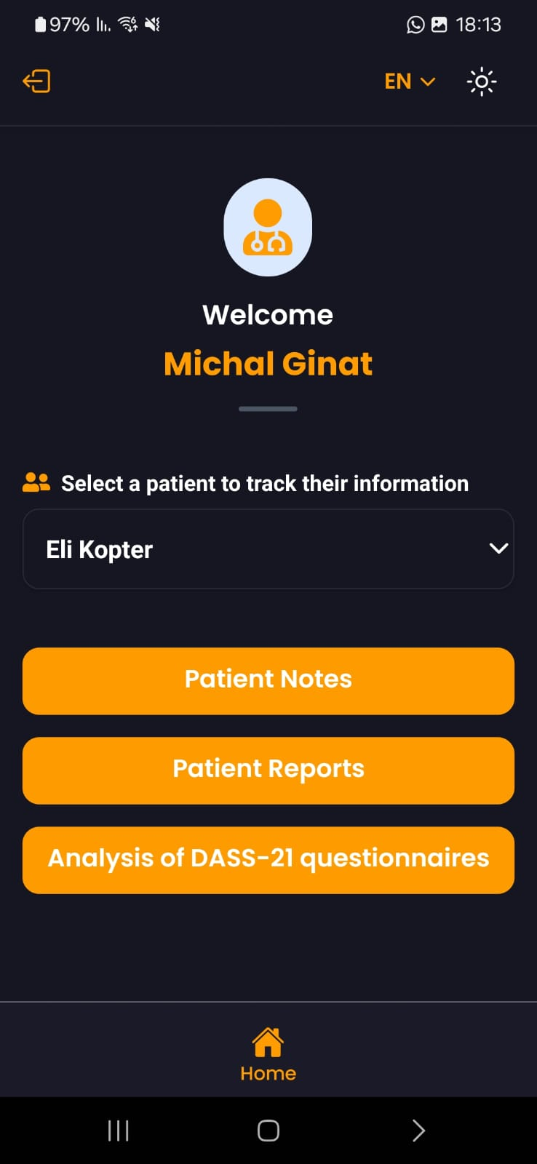

*fig 35. Patient’s information Page*

# 8.7.5 Analysis of DASS-21 questionnaire screen:

* **Purpose:** This screen displays the results of the DASS-21 questionnaire. It provides a summary of the user's latest assessment results and a history of past assessments.
* **Key Elements:**
  + **Latest Assessment Results:**
    - Displays the user's latest scores for depression, anxiety, and stress.
  + **Assessment History:**
    - Displays a list of previous DASS-21 assessments with their respective datesand scores.

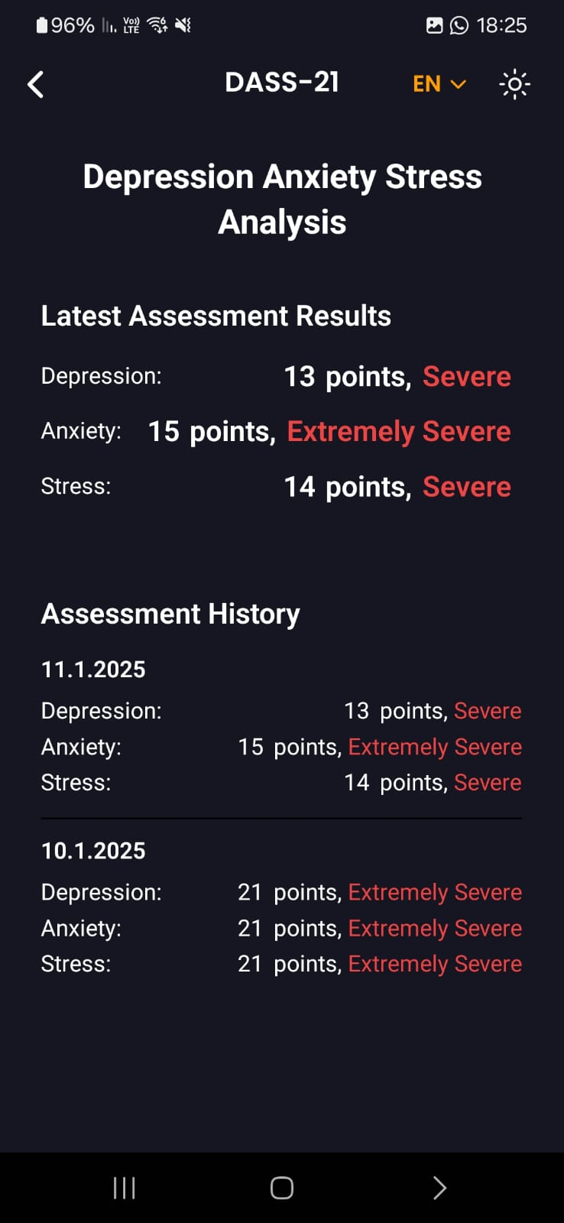

*fig 36. Analysis of DASS-21 questionnaire screen*

## 9. Maintenance Guide

# 9.1 Development Environment Setup

# 9.1.1 Prerequisites:

* Node.js (at least 20.18.0 version)
* VS Code or similar IDE
* MongoDB account (for database)
* Git
* EXPO CLI (for real-time testing, build, and deploy):
  + Install globally: npm install -g expo-cli
  + Required version: 52.x or higher
  + Expo account (sign up at expo.dev)
  + Expo Go app installed on mobile device for testing
* Google account for Firebase Authentication
* Render account (for deployment)
* Java Development Kit (JDK-17):
* Set JAVA_HOME environment variable
* Add to system PATH
* Android SDK: Install Android SDK (needed for APK generation)

# 9.1.2 Repository Structure

Below is a simplified view of the project's main directories and their purposes. This is a shortened version focusing on the essential components:

project/  
|

|--- Client/ # React Native + Expo mobile app

| |--- app/ # Main application code

| |--- (admin)/ # Admin screen management

| |--- (auth)/ # Authentication

| |--- (patient)/ # Patient screen management

| |--- (therapist)/ # Therapist screen management

| |--- components/ # Reusable UI components

| |--- services/ # API and external services

| |--- context/ # React Context for state management

| |--- types/ # TypeScript definitions

| |--- .env # Environment variables

| |--- package.json # Dependencies and scripts

|

|--- Server/ # Node.js + Express server

| |--- src/ # Main server code

| |--- controllers/ # Request handlers

| |--- models/ # Database models

| |--- routes/ # API routes

| |--- services/ # Business logic

| |--- .env # Environment variables

| |--- package.json # Dependencies and scripts

# 9.2 Installation Instructions

# 9.2.1 Clone GitHub repository:

1. Launch Git Bash terminal
2. Navigate to your desired installation directory: cd path/to/your/directory
3. Clone the project repository: git clone https://github.com/GalPolak98/CozySpace.git

# 9.2.2 Backend Setup (Local Development):

1. Open a new terminal in your IDE (e.g., Visual Studio Code)
2. Navigate to the server directory from the project root: cd Server
3. Install server dependencies: npm install
4. Create and configure environment variables: cp .env.example .env

* Open .env file and configure required variables

1. Run the server locally: npm run start

# 9.2.3 Mobile Application Setup (Local Development):

1. Open a new terminal in your IDE (e.g., Visual Studio Code)
2. Navigate to the client directory from the project root: cd Client
3. Install client dependencies: npm install
4. Create and configure environment variables: cp .env.example .env

* Open .env file and configure required variables

1. Add google-services.json file:

* Go to Firebase Console > Our Project > Project Settings > Your Apps
* Under "Add app", choose Android and register app
* Download google-services.json
* Place the file in the Client/ directory
* Update app.json, ensure the android configuration matches your Firebase setup: under the "android" section, update the package name from google-services.json.

1. Launch the Expo development server: npm run start
2. Switch to Expo Go mode: Press 's' in the terminal when the Metro Bundler starts
3. Connect your mobile device:

* iOS: Open your device's camera and scan the QR code
* Android: Open Expo Go app and scan the QR code using the app's scanner

# 9.2.4 Backend Deployment (Render):

You can either:

A. Use existing deployment:

1. URL: <https://anxiease.onrender.com>
2. Note: This URL should be used in your mobile app configuration

B. Create your own deployment:

1. Go to render.com and login
2. Click on 'add new'
3. Create a new Web Service
4. Connect our GitHub repository
5. Configure the service:

* Name: project name
* Environment: Node
* Branch: master
* Root Directory: Server
* Build Command: npm install && npm run build
* Start Command: node dist/app.js
* Environment Variables: Copy from .env

1. Click "Create Web Service"
2. Note the deployed **URL for mobile app** configuration

# 

# 9.2.5 Mobile App Local Build (APK):

First-Time Project Setup (Before First Build):

1. Open a new terminal, for example in VS Code
2. Generate native code: npx expo prebuild
3. Create local.properties file:

* Navigate to the android folder: cd android
* Create new file named local.properties
* Add your Android SDK path: sdk.dir=C:\\Users\\YourUsername\\AppData\\Local\\Android\\Sdk
* Note: Replace 'YourUsername' with your actual Windows username

1. Update gradle.properties:

* Open android/gradle.properties
* Add Java path:   
  org.gradle.java.home=C:\\Program Files\\Eclipse Adoptium\\jdk-17.0.13.11-hotspot

1. Modify Android Manifest:

* Open android/app/src/main/AndroidManifest.xml
* Find the line with android:supportsRtl="true"
* Change it to android:supportsRtl="false"

1. Create Keystore:

* Navigate to your project's android/app folder: cd android/app
* Generate keystore file using keytool command:   
  keytool -genkeypair -v -storetype PKCS12 -keystore my-release-key.keystore -alias my-key-alias -keyalg RSA -keysize 2048 -validity 10000
* You will be prompted to:

Enter a password for the keystore

Enter your name

Enter your organizational unit

Enter your organization

Enter your city

Enter your state

Enter your country code

Confirm the information is correct by typing 'yes'

* Save these details securely: Keystore password, Key alias: "my-key-alias", Key password You will need these for the build configuration.

1. Place keystore file:

* Copy your keystore file to android/app/
* Name example: my-release-key.keystore

1. Update signing configuration:

* Open android/app/build.gradle
* Add signing configuration:

|  |
| --- |
| android {  signingConfigs {  release {  storeFile file("my-release-key.keystore")  storePassword "your-store-password"  keyAlias "your-key-alias"  keyPassword "your-key-password"  }  }  buildTypes {  debug {  signingConfig signingConfigs.debug  }  release {  // Configures signing using our release keystore  signingConfig signingConfigs.release  …… The rest of the configuration….  }  } |

1. Navigate to Android directory and build the APK:

* cd android
* ./gradlew clean
* ./gradlew assembleRelease

Regular Build Process (Each Time You Want to Create an APK):

1. Open `babel.config.js` in the project root

* Add these lines inside the plugins array:

|  |
| --- |
| plugins: [  ......,  ["module:react-native-dotenv", {  "moduleName": "@env",  "path": ".env",  "blacklist": null,  "whitelist": null,  "safe": false,  "allowUndefined": true  }],  ] |

1. Generate native code: npx expo prebuild
2. Navigate to Android directory and build:

* cd android
* ./gradlew clean
* ./gradlew assembleRelease

1. Note: For local development, don't forget to:

* Remove the dotenv plugin configuration from babel.config.js
* Clear cache with npx expo start -c

# 9.2.6 iOS Deployment Note:

- For development:

1. iOS testing works through Expo Go app
2. Can scan QR code with iOS device camera

- For production deployment:

1. Currently only Android APK build is implemented
2. iOS deployment requires Apple Developer Account ($99/year)
3. iOS production build not implemented due to account requirement

## 9.3 Environment Configuration

## 9.3.1 Server Environment Variables (.env):

|  |
| --- |
| PORT =  MONGO_PASSWORD =  SENDGRID_API_KEY =  FROM_EMAIL =  EMERGENCY_CONTACT_EMAIL = |

PORT

Used for: Defining server port number.

Example: 3000

MONGO_PASSWORD

Used for: MongoDB Atlas database authentication.

How to obtain: MongoDB Atlas (click on the relevant project) > Database Access > Create/Edit User > Set/Reset Password

SENDGRID_API_KEY

Used for: Sending email from the system when the person is talking to a chatbot and suicidal thoughts are detected.

How to obtain:

1. Create account at SendGrid (<https://sendgrid.com>)

2. Navigate to Settings -> API Keys

3. Create new API key with email sending permissions

FROM_EMAIL

Used for: System email sender address.

Must be verified in SendGrid

How to verify in SendGrid:

1. Log into SendGrid dashboard (<https://app.sendgrid.com>)

2. Navigate to Settings > Sender Authentication

3. Choose either:

- Single Sender Verification (for one email)

- Domain Authentication (for entire domain)

4. For Single Sender:

- Click "Create New Sender"

- Fill in sender details including the FROM_EMAIL

- SendGrid will send verification email to that address

- Click verification link in the email

5. Once verified, use this email in your .env file

Example: "support@cozyspace.com"

EMERGENCY_CONTACT_EMAIL

Used for: Receiving notifications when users express suicidal thoughts while chatting (happens with the help of SendGrid)

Example: "emergency@cozyspace.com"

## 9.3.2 Mobile App Environment Variables (.env):

|  |
| --- |
| EXPO_PUBLIC_FIREBASE_API_KEY =  EXPO_PUBLIC_FIREBASE_AUTH_DOMAIN =  EXPO_PUBLIC_FIREBASE_PROJECT_ID =  EXPO_PUBLIC_FIREBASE_STORAGE_BUCKET =  EXPO_PUBLIC_FIREBASE_MESSAGING_SENDER_ID =  EXPO_PUBLIC_FIREBASE_APP_ID =  EXPO_PUBLIC_FIREBASE_MEASUREMENT_ID =  EXPO_PUBLIC_AZURE_API_KEY =  EXPO_PUBLIC_AZURE_MODEL_DEPLOYMENT =  EXPO_PUBLIC_AZURE_ENDPOINT =  EXPO_PUBLIC_AZURE_API_VERSION_DEPLOYMENT =  EXPO_PUBLIC_PUSH_TOKEN =  EXPO_PUBLIC_SERVER_URL =  EXPO_PUBLIC_WS_URL = |

Firebase Configuration:

- EXPO_PUBLIC_FIREBASE_API_KEY

- EXPO_PUBLIC_FIREBASE_AUTH_DOMAIN

- EXPO_PUBLIC_FIREBASE_PROJECT_ID

- EXPO_PUBLIC_FIREBASE_STORAGE_BUCKET

- EXPO_PUBLIC_FIREBASE_MESSAGING_SENDER_ID

- EXPO_PUBLIC_FIREBASE_APP_ID

- EXPO_PUBLIC_FIREBASE_MEASUREMENT_ID

How to obtain:

1. Go to Firebase Console (<https://console.firebase.google.com>)

2. Create new project or select existing

3. Go to Project Settings

4. Find the Firebase configuration object

5. Copy each value to corresponding environment variable

Azure OpenAI Configuration:

- EXPO_PUBLIC_AZURE_API_KEY

- EXPO_PUBLIC_AZURE_MODEL_DEPLOYMENT

- EXPO_PUBLIC_AZURE_ENDPOINT

- EXPO_PUBLIC_AZURE_API_VERSION_DEPLOYMENT

How to obtain:

1. Check quota availability:

- Go to [https://ai.azure.com](https://ai.azure.com/)

- Click "Deployments" > "Manage quota"

- Check for GPT-4 quota availability

2. If no quota:

- Request via Microsoft Form: [Microsoft Form](https://customervoice.microsoft.com/Pages/ResponsePage.aspx?id=v4j5cvGGr0GRqy180BHbR4xPXO648sJKt4GoXAed-0pUMFE1Rk9CU084RjA0TUlVSUlMWEQzVkJDNCQlQCN0PWcu)

- Wait for approval (2-10 business days)

3. Once you have quota:

- Go to [https://ai.azure.com](https://ai.azure.com/)

- Create new deployment:

* Model: GPT-4

* Deployment type: Standard (Pay-as-you-go)

- Copy configuration values:

* EXPO_PUBLIC_AZURE_MODEL_DEPLOYMENT: Your deployment name (like gpt-4)

* EXPO_PUBLIC_AZURE_ENDPOINT: Endpoint URL from Deployments page

* EXPO_PUBLIC_AZURE_API_KEY: Key from "Key and Endpoint" section

* EXPO_PUBLIC_AZURE_API_VERSION_DEPLOYMENT: "2024-08-01-preview"

Pricing and Student Benefits:

- Standard (Pay-as-you-go) pricing for GPT-4:

* GPT-4-Turbo (Recommended):

- Input: $10 per 1M tokens

- Output: $30 per 1M tokens

- Context window: 128K tokens

- Student Benefits:

* Sign up at <https://azure.microsoft.com/free/students>

* Get $100 free credit valid for 12 months

* Can process approximately with GPT-4-Turbo:

- ~2.5M input tokens or

- ~830K output tokens

Push Notifications:

- EXPO_PUBLIC_PUSH_TOKEN

Used for: Push notification services (pop up alert when anxiety is detected)

How to obtain:  
 1. Create account on Expo (<https://expo.dev>, if you haven't created one yet)

2. Install Expo CLI: npm install -g expo-cli (make sure you have installed)

3. In your project:

- Run: expo login

- Run: expo notifications:generate-token

- Copy the generated token

Server Connection:

- EXPO_PUBLIC_SERVER_URL

Description: URL of your deployed backend server

Example for development: "http://localhost:3000"

Example for production: "https://your-server.onrender.com"

- EXPO_PUBLIC_WS_URL

Description: WebSocket URL for real-time communication

Example for development: "ws://localhost:3000"

Example for production: "wss://your-server.onrender.com"

# 9.4 Database Management

### 9.4.1 MongoDB Collections Structure:

1. Users Collection:

Purpose: Provides quick identification of user type during login to provide fast routing.

Schema Structure:

|  |
| --- |
| {  _id: ObjectId,  userId: string, // Firebase Authentication ID  userType: string // "patient" or "therapist" or "admin"  } |

1. Patients Collection:

Purpose: Stores patient-specific information and health data.

Schema Structure:

|  |
| --- |
| {  _id: ObjectId,  userId: string, // Firebase Authentication ID  personalInfo: {  firstName: string,  lastName: string,  email: string,  gender: string // "male" or "female"  },  therapistInfo: {  selectedTherapistId: string | null, // Firebase ID of assigned therapist  dataSharing: {  anxietyTracking: boolean,  personalDocumentation: boolean  }  },  toolsPreferences: {  smartJewelry: {  enabled: boolean,  vibrationAlerts: boolean  },  musicTherapy: {  enabled: boolean,  selectedTrackId: string | null  }  },  guidedNotes: [{  anxietyRating: number,  description: string,  trigger: string,  copingStrategies: string,  physicalSymptoms: string,  emotionalState: string,  selfTalk: string,  timestamp: string  }],  notes: [{  _id: ObjectId,  content: string,  timestamp: string  }],  recordings: [{  uri: string,  timestamp: string  }],  breathingSessions: [{  timestamp: string,  durationSec: number,  patternType: string,  completed: boolean  }],  dassResponses: [{  timestamp: string,  answers: [{  questionId: number,  score: number // 0-3  }],  totalScore: number,  analysis: {  scaleScores: {  depression: number,  anxiety: number,  stress: number  },  severity: {  depression: string,  anxiety: string,  stress: string  }  }  }]  } |

1. Therapists Collection:

Purpose: Stores therapist information and their assigned patients.

Schema Structure:

|  |
| --- |
| {  _id: ObjectId,  userId: string, // Firebase Authentication ID  personalInfo: {  firstName: string,  lastName: string,  email: string,  gender: string // "male" or "female"  },  professionalInfo: {  educationLevel: string,  experienceLevel: string,  workplace: string,  specialization: string,  licenseNumber: string  },  patients: [{  userId: string, // Patient's Firebase ID  fullName: string // Patient's full name  }]  } |

1. Features Collection:

Purpose: Allows admin users to control system-wide feature availability through on/off toggles.

Schema Structure:

|  |
| --- |
| {  _id: ObjectId,  chat: boolean, // Admin toggle for chat feature  guidedNote: boolean, // Admin toggle for guided notes  directNote: boolean, // Admin toggle for direct notes  breathingExercises: boolean, // Admin toggle for breathing exercises  anxietyDataViewer: boolean, // Admin toggle for anxiety data viewer  recordings: boolean, // Admin toggle for recordings  updatedAt: Date // Last modification timestamp  } |

# 9.5 Server Limitations (our server deployment)

# 9.5.1 Render Free Tier Limitations

1. Monthly Usage Limits:

* 750 hours of instance runtime
* 100 GB bandwidth
* 500 build minutes

1. Server Sleep Mode:

* The server automatically spins down after 15 minutes of inactivity
* First access after inactivity requires manual activation
* To activate: Visit <https://anxiease.onrender.com/> and wait for "Route not found" message
* Initial loading time: ~1-2 minutes

# 10. References

1. Bhattacharya, S., Goicoechea, C., Heshmati, S., Carpenter, J. K., & Hofmann, S. G. (2023). Efficacy of cognitive behavioral therapy for anxiety-related disorders: A meta-analysis of recent literature. Current psychiatry reports, 25(1), 19-30.
2. Bonato, P. (2010). Wearable sensors and systems. IEEE Engineering in Medicine and Biology Magazine, 29(3), 25-36.
3. Can, Y. S., Arnrich, B., & Ersoy, C. (2019). Stress detection in daily life scenarios using smart phones and wearable sensors: A survey. *Journal of biomedical informatics*, *92*, 103139.‏
4. Drissi, N., Ouhbi, S., Idrissi, M. A. J., & Ghogho, M. (2020). An analysis on self-management and treatment-related functionality and characteristics of highly rated anxiety apps. *International journal of medical informatics*, *141*, 104243.‏
5. Gülcüoğlu, E., Ustun, A. B., & Seyhan, N. (2021). Comparison of Flutter and React Native Platforms. *İnternet Uygulamaları ve Yönetimi Dergisi*, *12*(2), 129-143.
6. Hickey, B. A., Chalmers, T., Newton, P., Lin, C. T., Sibbritt, D., McLachlan, C. S., ... & Lal, S. (2021). Smart devices and wearable technologies to detect and monitor mental health conditions and stress: A systematic review. *Sensors*, *21*(10), 3461.
7. Ihmig, F. R., Neurohr-Parakenings, F., Schäfer, S. K., Lass-Hennemann, J., & Michael, T. (2020). On-line anxiety level detection from biosignals: Machine learning based on a randomized controlled trial with spider-fearful individuals. *Plos one*, *15*(6), e0231517.‏
8. Javaid, S. F., Hashim, I. J., Hashim, M. J., Stip, E., Samad, M. A., & Ahbabi, A. A. (2023). Epidemiology of anxiety disorders: global burden and sociodemographic associations. *Middle East Current Psychiatry*, *30*(1), 44.
9. Nakao, M., Shirotsuki, K., & Sugaya, N. (2021). Cognitive–behavioral therapy for management of mental health and stress-related disorders: Recent advances in techniques and technologies. *BioPsychoSocial medicine*, *15*(1), 16.
10. Sharma, N., & Gedeon, T. (2012). Objective measures, sensors and computational techniques for stress recognition and classification: A survey. *Computer methods and programs in biomedicine*, *108*(3), 1287-1301.‏
11. Shaukat-Jali, R., van Zalk, N., & Boyle, D. E. (2021). Detecting subclinical social anxiety using physiological data from a wrist-worn wearable: small-scale feasibility study. *JMIR Formative Research*, *5*(10), e32656.‏
12. Verma, N., Singh, S., & Prasad, D. (2022). A review on existing IoT architecture and communication protocols used in healthcare monitoring system. *Journal of The Institution of Engineers (India): Series B*, *103*(1), 245-257.
13. [https://trends.google.com/trends/explore?date=2022-07-20%202024-07-20&geo= IL&q=%D7%97%D7%A8%D7%93%D7%94&hl=en-GB](https://trends.google.com/trends/explore?date=2022-07-20%202024-07-20&geo=IL&q=%D7%97%D7%A8%D7%93%D7%94&hl=en-GB)
14. <https://alphacode.dev/backend/top-backend-technologies-2024/>
15. <https://www.turing.com/resources/backend-frameworks#top-10-backend-frameworks-in-2024>
16. <https://www.lambdatest.com/blog/flutter-vs-react-native/>
17. <https://www.bitcot.com/best-database-for-web-applications/#:~:text=Leaders%20for%20modern%20web%20apps,reach%20%2471.6%20billion%20by%202026>.
18. <https://github.com/sidesh27/Anxiety-Detection?tab=readme-ov-file>
19. <https://github.com/rs2416/Detecting_Social_Anxiety>
20. <https://aws.amazon.com/iot-core/faqs/>
21. <https://db-engines.com/en/system/MongoDB>
22. <https://db-engines.com/en/system/PostgreSQL>
23. <https://www.spirehealth.com/technology>
24. <https://www.feeltherapeutics.com/>